EPA Region 8 Revised Total Coliform Rule

Sample Siting Plan Instructions

Why do I need to develop a Revised Total Coliform Rule (RTCR) Sample Siting Plan?
The purpose of this plan is to specify where in the distribution system Routine and Repeat bacteriological samples will be collected to ensure they are representative of the water quality in your system. The original Sample Siting Plan must be kept on-site for use by sampling personnel. Beginning April 1, 2016, under the RTCR, every water system will be required to collect bacteriological samples monthly.

The RTCR requires every public water system to develop an RTCR Sample Siting Plan prior to April 1, 2016. These plans are subject to review and revision by EPA. You must include the following elements in your plan:

- A list of sampling locations: (See blank sample plan chart and example Addendum C.)
- You will need to indicate the sites for Routine and Repeat bacteriological monitoring in your distribution system; and
- Any source water sampling sites if subject to the Ground Water Rule.

- A map of the distribution system showing locations of your Routine and Repeat sample sites and your source water, as described in the Sample Siting Plan. You can use a diagram, distribution system map, aerial photo, etc. Clearly indicate if there are multiple distribution systems and if those distribution systems are connected to each other. Note: You cannot use the schematic that indicates your nitrate sampling point. (See sample plan map examples Addendum B.)

Where to submit your plan:
Send a copy of your RTCR sample siting plan via mail, e-mail, or fax to:

EPA Region 8
Drinking Water Program 8WD-SDA
1595 Wynkoop Street
Denver, CO 80202
Attn: RTCR Rule Manager
Fax: (877) 876-9101
Email: R8DWU@epa.gov

How to choose a laboratory:
Not all laboratories have been approved and certified to analyze for all the required drinking water contaminants. You must send your samples to a laboratory that is certified for the specific samples that you are submitting. For a list of certified labs, visit the EPA Region 8 website: https://www.epa.gov/region8-waterops/general-sampling-information and click the certified lab link.

General Requirements

Process for selecting sample sites and rotation:
Review the layout of your distribution system and choose RTCR sample sites that will represent each area of the distribution system if sampled on a monthly rotating basis throughout an entire year or open season. Be sure to take into account non-permanent sources (seasonal or interim). These sources need to be represented within your siting plan. If your water system has multiple (completely separated) distribution systems, you must select sample sites within each separate distribution system for each month you are serving water to the public. If you serve more than 4,901 people (collect 6 or more samples per month) you cannot collect all the samples on the same day. They must be collected at regular intervals throughout the month [40 CFR 141.853(a)(2)].

The Sample Siting Plan may need to be updated periodically to account for system changes (such as population changes, new housing or commercial development, new sources, change in operating season, change in treatment, etc). The plan should be reviewed annually and must be available during your sanitary survey to incorporate any changes. Submit any revisions to the EPA regional office as soon as they occur.

Routine Monitoring Requirement

Unless otherwise specified in your monitoring and reporting requirements, most systems will be placed on the monitoring schedule seen in Addendum A of this document.

Refer to the charts in Addendum B as examples for formatting the Sample Siting Plan. The following must be included in the plan (a blank chart is in Addendum C):
- Routine sampling location(s);
- Repeat sampling locations (only used if your Routine sample is TC+);
- Ground Water Rule (GWR) source sample location(s) for systems using groundwater sources. (Triggered GWR source sample(s) are only required if your Routine sample result is TC+. You must sample every groundwater source in use at the time of the TC+ Routine sample.)

Repeat Monitoring

After April 1, 2016, under the RTCR, systems must collect no fewer than three Repeat samples for each TC+ Routine sample. This requirement will apply to all systems.
- All Repeat samples need to be taken within 24 hours of notification of a TC+ Routine sample. If you cannot make this timeframe, you must contact EPA Region 8 within 24 hours to request an extension;
- One Repeat sample is required to be taken from the same tap as the original TC+ sample;
- One Repeat sample must be taken at a tap within five service connections upstream of the original TC+ Routine sample, and one must be taken at a tap within five service connections downstream of the original TC+ Routine sample.

Take note of your Routine sample locations. Can you take proper Repeat samples based on your current choices of Routine sampling sites? If not, you will need to reevaluate your Routine sites and choose another location. If you do not have a distribution system (i.e., hand pump), upstream and downstream locations may not exist. In this case, you must collect multiple samples at the original location to count as Repeat samples.

Follow this same format of choosing representative Routine and Repeat sample locations (as shown in Addendum B) but expand as necessary if your system is required to take more than one sample per month (see Example #2). Seasonal systems only have to sample during their operating season (see Example #2).

Submitting Samples to the Laboratory:
- In order for EPA to confirm the locations of your samples and the types of samples (Routine, Repeat or Special), EPA encourages you to submit additional details about the sampling locations of your RTCR samples to the lab. Along with the lab’s chain of custody form, you can use the “Source Water Sampling-Triggered Source Monitoring Sample Collection and Reporting Form” found on the EPA Region 8 website at: https://www.epa.gov/region8-waterops/revised-total-coliform-rule-lab-sampling-form

E. coli Testing and E. coli MCL Compliance Determination

Any TC+ sample result must automatically be analyzed for E. coli (EC) by your lab. Any EC+ Repeat sample or any TC+ Repeat sample following an EC+ Routine sample constitutes an E. coli MCL violation. All E. coli MCL violations are situations that require you to contact EPA Region 8 immediately and distribute public notice including a boil water order to your customers.

Groundwater source sampling:

Triggered Source Water Monitoring Requirement

Your system will need to conduct triggered source water sampling if you use a groundwater source and have a TC+ Routine sample result. Review your Monitoring and Reporting Requirements sheet to verify if source water monitoring is necessary under these conditions. If you need to conduct this monitoring, keep the following in mind:
- Within 24-hours of notification that a Routine RTCR distribution system sample is TC+, you must collect a raw water sample from each groundwater source that was in use at that time for every Routine TC+ sample (e.g., if you have three Routine TC+ samples, you will need to collect three source samples from each groundwater source). This sample must be analyzed for E. coli.
- You are encouraged to report this data to the lab using the “Source Water Sampling-Triggered Source Monitoring Sample Collection and Reporting Form” found on our website at:
https://www.epa.gov/region8-waterops/wyoming-and-tribal-triggered-groundwater-source-sampling-form
- If you need further assistance on the Ground Water Rule and the required steps after a Routine TC+ sample, please consult: https://www.epa.gov/region8-waterops/epa-region-8-drinking-water-unit-tech-tips-follow-unsafetotal-coliform-positive

If the system received EPA Region 8 approval to use a sampling site that represents more than one groundwater source, please indicate that on the sample collection and monitoring form mentioned above that is submitted with your samples.

For instructions on how to properly label your RTCR and GWR samples please see the “RTCR and GWR Sample Labeling Instructions” form on the Region 8 website: https://www.epa.gov/region8-waterops/rtcr-and-gwr-sample-labeling-instructions

Disinfectant (chlorine) residual monitoring:

If you disinfect, your system may need to conduct residual disinfectant monitoring in the distribution system for the Disinfection By-Product Rule and/or the Surface Water Treatment Rule. Review your Monitoring and Reporting Requirements sheet to verify if disinfectant monitoring is necessary. If you need to conduct this monitoring, keep the following in mind:

- The residual disinfectant must be measured at the same time and the same location as each total coliform bacteria sample.
- These measurements must be conducted in the field by a certified operator (or under the direction of the certified operator).
- Residual disinfectant measurements must be written on each total coliform sample slip when it is submitted to the laboratory.
- Ask your laboratory to forward this information to EPA along with the sample results.

Depending on the disinfectant used in the distribution system, ensure you are measuring the proper disinfectant residual:
- If chlorine is used, the disinfectant residual must be measured as free, total, or combined chlorine
- If chloramines are used, the disinfectant residual must be measured as total chlorine

Addendum A: Required number of monthly Routine samples under the Revised Total Coliform Rule

Sampling requirements for all water systems*:

Population served/day | Routine Samples/Month | Population served/day | Routine Samples/Month
25-1,000 | 1 | 8501-12900 | 10
1001-2500 | 2 | 12901-17200 | 15
2501-3300 | 3 | 17201-21500 | 20
3301-4100 | 4 | 21501-25000 | 25
4101-4900 | 5 | 25001-33000 | 30
4901-5800 | 6 | 33001-41000 | 40
5801-6700 | 7 | 41001-50000 | 50
6701-7600 | 8 | 50001-59000 | 60
7601-8500 | 9 | 59001-70000 | 70

* The number of required samples may be dependent on individual wells and distribution systems under your PWS ID. For instance, if you serve 500 people per day but you have two wells that each serve completely different distribution systems you will be required to monitoring each distribution system each month.
Addendum B: Examples of RTCR Sample Siting Plans

Example #1: Chart - Single Source/Single Distribution (Population ≤ 1000; 1 sample/month)
PWS Name: EPA Water System |  | PWSID: WY5600xxx | __1_ (#) Sample(s)/month
Month | Routine Sample Location | Repeat Sample Location | GWR sample location (any sources running at the time of a routine TC+)
January | Unit #11 (DIST) | 1) (Same as routine location) | GW -1 (WL01)
 | (within 5 taps upstream) | 2) Unit #14 (DIST)
 | (within 5 taps downstream) | 3) Unit #8 (DIST)
February | Unit # 22 (DIST) | 1) (Same as routine location) | GW -1 (WL01)
 | (within 5 taps upstream) | 2) Unit # 26 (DIST)
 | (within 5 taps downstream) | 3) Unit # 17 (DIST)
March | Unit # 4 (DIST) | 1) (Same as routine location) | GW -1 (WL01)
 | (within 5 taps upstream) | 2) Unit # 9 (DIST)
 | (within 5 taps downstream) | 3) Unit # 1 (DIST)
April | Unit #11 (DIST) | 1) (Same as routine location) | GW -1 (WL01)
 | (within 5 taps upstream) | 2) Unit #14 (DIST)
 | (within 5 taps downstream) | 3) Unit #8 (DIST)
May | Unit # 22 (DIST) | 1) (Same as routine location) | GW -1 (WL01)
 | (within 5 taps upstream) | 2) Unit # 26 (DIST)
 | (within 5 taps downstream) | 3) Unit # 17 (DIST)
June | Unit # 4 (DIST) | 1) (Same as routine location) | GW -1 (WL01)
 | (within 5 taps upstream) | 2) Unit # 9 (DIST)
 | (within 5 taps downstream) | 3) Unit # 1 (DIST)
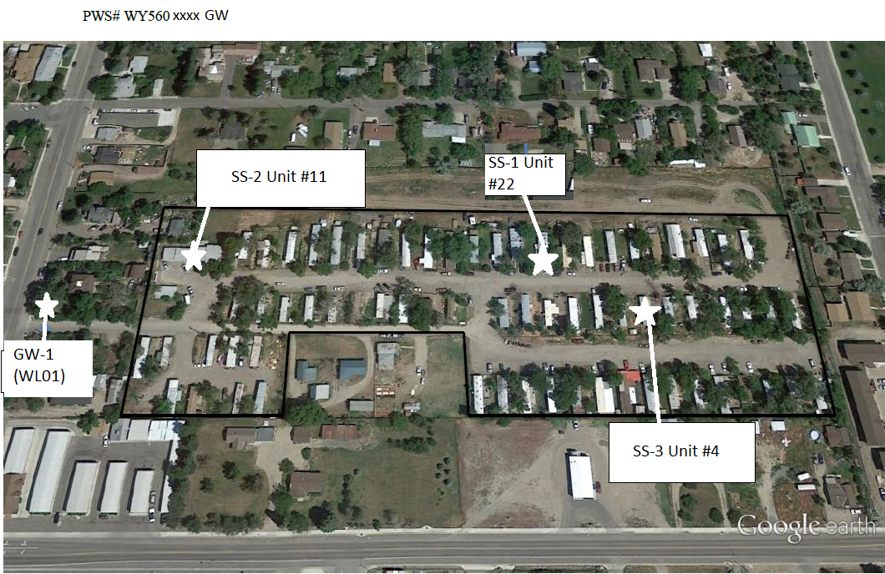
Example #1: Map for a Single Source/Single Distribution PWS (Population ≤ 1000; 1 sample/month)

Example 2: Chart - Multiple Sources/Multiple Distribution (Population ≤ 1000; 2 samples/month)
PWS Name: EPA Water System |  | PWSID: WY5600xxx | __2_ (#) Sample(s)/month
Month | Routine Sample Location | Repeat Sample Location | GWR sample location (any sources running at the time of a routine TC+)
Girls Camp Distribution System
January | CLOSED | 1) (Same as routine location)
 | (within 5 taps upstream)
 | (within 5 taps downstream)
February | CLOSED | 1) (Same as routine location)
 | (within 5 taps upstream)
 | (within 5 taps downstream)
March | CLOSED | 1) (Same as routine location)
 | (within 5 taps upstream)
 | (within 5 taps downstream)
April | CLOSED - Seasonal Startup | 1) (Same as routine location) | Will complete Seasonal Startup Checklist in April
 | (within 5 taps upstream)
 | (within 5 taps downstream)
May | Juniper Cabin (DIST) | 1) (Same as routine location) | GW -1 (WL01)
 | (within 5 taps upstream) | 2) Cedar Cabin (DIST)
 | (within 5 taps downstream) | 3) Lodgepole Cabin (DIST)
June | Lodgepole Cabin (DIST) | 1) (Same as routine location) | GW -1 (WL01)
 | (within 5 taps upstream) | 2) Cedar Cabin (DIST)
 | (within 5 taps downstream) | 3) Juniper (DIST)
July | Cedar Cabin (DIST) | 1) (Same as routine location) | GW -1 (WL01)
 | (within 5 taps upstream) | 2) Juniper Cabin (DIST)
 | (within 5 taps downstream) | 3) Lodgepole Cabin (DIST)
August | Juniper Cabin (DIST) | 1) (Same as routine location) | GW -1 (WL01)
 | (within 5 taps upstream) | 2) Cedar Cabin (DIST)
 | (within 5 taps downstream) | 3) Lodgepole Cabin (DIST)
September | CLOSED | 1) (Same as routine location)
 | (within 5 taps upstream)
 | (within 5 taps downstream)
October | CLOSED | 1) (Same as routine location)
 | (within 5 taps upstream)
 | (within 5 taps downstream)
November | CLOSED | 1) (Same as routine location)
 | (within 5 taps upstream)
 | (within 5 taps downstream)
December | CLOSED | 1) (Same as routine location)
 | (within 5 taps upstream)
 | (within 5 taps downstream)
Boys Camp Distribution System
January | CLOSED | 1) (Same as routine location)
 | (within 5 taps upstream)
 | (within 5 taps downstream)
February | CLOSED | 1) (Same as routine location)
 | (within 5 taps upstream)
 | (within 5 taps downstream)
March | CLOSED | 1) (Same as routine location)
 | (within 5 taps upstream)
 | (within 5 taps downstream)
April | CLOSED - Seasonal Startup | 1) (Same as routine location) | Will complete Seasonal Startup Checklist in April
 | (within 5 taps upstream)
 | (within 5 taps downstream)
May | Main Fountain (DIST) | 1) (Same as routine location) | GW - 2 (WL02)
 | (within 5 taps upstream) | 2) Infirmary (DIST)
 | (within 5 taps downstream) | 3) Craft Shop (DIST)
June | Craft Shop (DIST) | 1) (Same as routine location) | GW - 2 (WL02)
 | (within 5 taps upstream) | 2) Main Fountain (DIST)
 | (within 5 taps downstream) | 3) Infirmary (DIST)
July | Infirmary (DIST) | 1) (Same as routine location) | GW - 2 (WL02)
 | (within 5 taps upstream) | 2) Craft Shop (DIST)
 | (within 5 taps downstream) | 3) Main Fountain (DIST)
August | Main Fountain (DIST) | 1) (Same as routine location) | GW - 2 (WL02)
 | (within 5 taps upstream) | 2) Infirmary (DIST)
 | (within 5 taps downstream) | 3) Craft Shop (DIST)
September | CLOSED | 1) (Same as routine location)
 | (within 5 taps upstream)
 | (within 5 taps downstream)

Example #2: Map for a system with Multiple Sources/Multiple Distributions PWS (Population ≤ 1000; 2 samples/month)

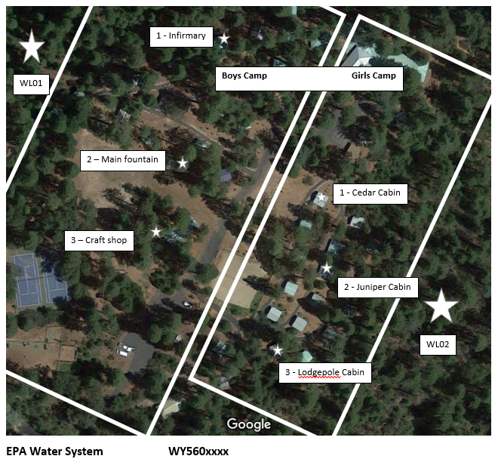

Addendum C: Example form. Expand the following table as necessary. Feel free to detach and use this example form:
 | PWS NAME: | PWS ID #:
(sample/mo=__) | Routine sample location | Repeat sample locations | GWR sample location (any sources in use at the time of a routine TC+)
January | 1) | 1) (same as routine location)
 |  | 2)
 |  | 3)
February | 1) | 1) (same as routine location)
 |  | 2)
 |  | 3)
March | 1) | 1) (same as routine location)
 |  | 2)
 |  | 3)
April | 1) | 1) (same as routine location)
 |  | 2)
 |  | 3)
May | 1) | 1) (same as routine location)
 |  | 2)
 |  | 3)
June | 1) | 1) (same as routine location)
 |  | 2)
 |  | 3)
July | 1) | 1) (same as routine location)
 |  | 2)
 |  | 3)
August | 1) | 1) (same as routine location)
 |  | 2)
 |  | 3)
September | 1) | 1) (same as routine location)
 |  | 2)
 |  | 3)
October | 1) | 1) (same as routine location)
 |  | 2)
 |  | 3)
November | 1) | 1) (same as routine location)
 |  | 2)
 |  | 3)
December | 1) | 1) (same as routine location)
 |  | 2)
 |  | 3)

