NPDES Security Enhancement: Details for MSGP Preparers and Duly Authorized Representative for Certifiers (DARCs)
January 27, 2016

Information for Preparers or Duly Authorized Representative for Certifiers (DARCs):
- New NOIs: You can still prepare New NOIs and send them to a Certifier as before, but if you need access to that NPDES ID later you will need to request it from the Certifier. (You will not automatically receive access to the NPDES ID for subsequent form submissions like the Certifier will.)
- For Change NOIs, NOTs, and Annual Reports:
  - You will need to request NPDES ID access from either the Certifier or a Permit Administrator before you can prepare Change NOIs, NOTs, or Annual Reports.
  - For DARCs, you will also need NPDES ID access to sign and submit Annual Reports, which you will need to request.
  - See “Requesting Access to a NPDES ID” below for directions on requesting NPDES ID access.

Requesting Access to a NPDES ID:
- A Certifier or Permit Administrator must have access to a NPDES ID to grant you access
- Log in to CDX at https://cdx.epa.gov then enter NeT:
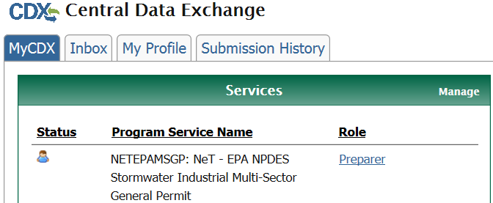
- Go into “Forms”:
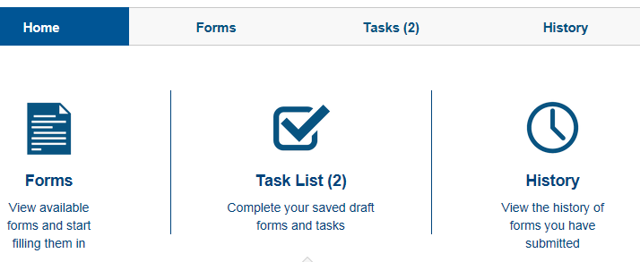
- Choose the “Request NPDES ID Access” form
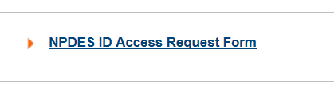
- Under “What action would you like to take?” choose “NPDES ID Access”
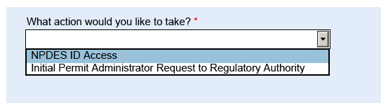
- Enter the NPDES ID and click Lookup
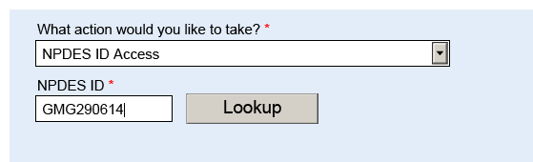
- Check the box below to confirm you have the right NPDES ID
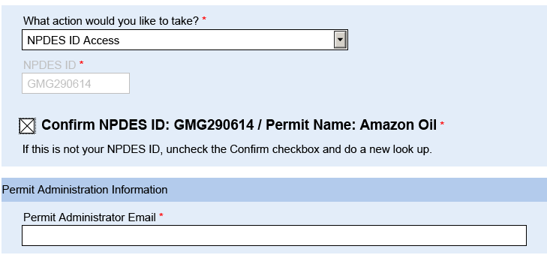
- Enter the email of the Certifier or Permit Administrator who already has access to the NPDES ID
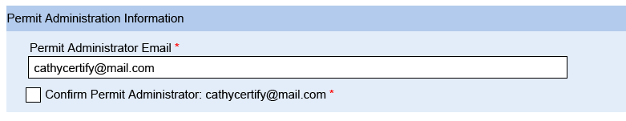
- Click the Confirm box and then Submit Now
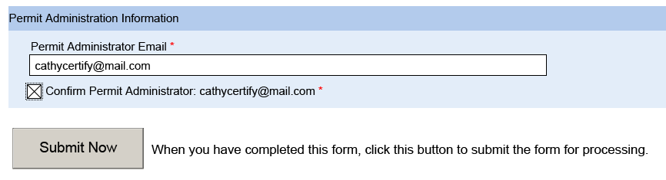
- The Certifier/Permit Administrator will need to log into NeT and approve or reject your request, as they would with a form you had prepared

