# PART I (From January 28 webinar)

**Q.** So will the EN passwords expire like the AQS passwords or will we be able to keep using the EN password indefinitely? (**Ryan Eberle**)

A. You can now logon to AQS using your EN userid and password. The EN passwords do not expire.

A valid password must meet the following rules:  
1) A password must have at least 8 characters.  
2) A password must contain at least one capital letter (‘A’-‘Z’).  
3) A password must contain at least one numeric character (‘0’-‘9’)

**Q.** Can we change the EN email? (**Robert Lacaillade**)

A. If you have questions about the userid used to logon to the EN Services Center, then contact EN Support via <https://enservices.epa.gov/ContactUs.aspx>. In AQS, you can change the EN User ID field in AQS on the Admin / Security page, however, in order for AQS to work properly, it needs to match your actual EN userid.

**Q.** Good call on excluding protocol and does that increase the flexibility option for entering new method codes? (**Chris Ellis**)

A. Excluding protocols should not affect the entry of new method codes but should make it easier to enter data at new monitors.

**Q.** What is the preferred browser? Internet Explorer? (**Brian Woods**)

A. The preferred browser for AQS is Internet Explorer.

**Q.** How about Microsoft Edge? (**Russell Bowman**)

A. AQS does not currently work in Microsoft Edge, the replacement for Internet Explorer

**Q.** Our IT said Java support might be going away, or difficult. Will you be using Java for the foreseeable future? (**Robert Lacaillade**)

A. We are aware of the general trend for browsers to de-support Java applets and are working on a solution.

**Q.** Does a collocated monitor have to use the same method as a primary monitor? (**Robert Lacaillade**)

A. AQS does not require collocated monitors do not have to have the same method as a primary. However, 40 CFR Part 58 Appendix A has parameter specific rules about methods used for collocation.

**Q.** Doesn’t 88101 POC 2 insinuate collocation? (**Chris Ellis**)

A. POC never insinuates anything. Some agencies have guidelines for how they use POC, but those guidelines are not enforced in AQS nor does AQS enforce any rules for POCs. A collocated monitor must be set up using the proper monitor metadata in AQS.

**Q.** Will the agencies have to re-enter the collocation information in the QA collocation form? Or will this information be automatically be migrated to the QA Collocation form? (**Rayna Broadway**)

A: At this point there are no plans to automatically migrate collocation data.

**Q.** How do we code a monitor that is placed at a site due to State law? (**Stephen Shaw)**

A. This was clarified in the chat to mean network code. This is a question for your Regional AQS contact.

**Q.** May I ask what RB stands for? (**Simon Cheung**)

A. RB stands for Raw Blanks transaction.

**Q.** The rule about mass units and Blanks data doesn't go for air toxics, though, right? I've never had a problem loading blanks as concentrations. (**Jaime Hauser**).

A. Blanks for air toxics can be loaded with Concentration units. Blanks for Criteria Pollutants must be in mass units.

**Q.** I would like to concur with Jaime's request, we have issues occasionally with corrections and are also aware of the capability for individual corrections in AQS. It has not been intuitive for me and I have also called tech support at times. Also, for additional resources can you include the topic of fixing errors? (**Bill Chevalier**, **Jaime Contreras SLOAPCD)**

A. For information on correcting data in AQS, go to the AQS User’s Guide (http://www.epa.gov/sites/production/files/2015-10/documents/aqs_user_guide_2015.pdf) Correct Section beginning at page 41.

**Q.** On the maximum values report for CO is it possible to have two values on the same day? (**Daniel Ross**)

A. Yes. The guidance document for CO requires it. We will get this guidance document linked from the AQs web site.

**Q.** Can you also discuss the way AQS bins one point QC checks (AMP 256)? We have had some questions regarding the way AQS handles this data—also how do the reports handle the binning process when you run reports for a single quarter within a year. Also how does AQS bin these checks for ozone? (**Anthony Ross (EPA Region 5)**)

A. 40 CFR Part 58 Appendix A Section 3.2.1 requires: “A one-point quality check must be performed at least once every 2 weeks.” AQS implements this by defining two week intervals from the start of monitoring for the year, and counting the number of intervals with a check for the period of the report. For Ozone, the begin date is the first day of the Ozone season for the site.

**Q** Is there a way to make a correction to a data record in the preproduction screen. Say if a concentration is found to be a bad or coded wrong one has to delete the record in preproduction and then create a new record in CORRECT form. This can be laborious if one has a number of records that need corrected not because of an AQS error. (**Dave Ambrose**)

A. A data record can be corrected in a pre-production screen. There is no need to delete the record in pre-production and create a new record in the Correct form. For information on correcting data in AQS, go to the AQS User’s Guide (http://www.epa.gov/sites/production/files/2015-10/documents/aqs_user_guide_2015.pdf) Correct Section beginning at page 41.

**Q.** Is there a way to add a qualifier flag in bulk? 48 hours continuous. (**Stephen Shaw (SJVAPCD))**

A. Presently, this can only be done via the Batch process.

**Q.** Where is global search and replace? **Stephen Shaw (SJVAPCD)**:

A: Information on Global Search and Replace can be found on page 47 of the AQS User’s Guide at <http://www.epa.gov/sites/production/files/2015-10/documents/aqs_user_guide_2015.pdf>

**Q.** Is there a tutorial available on how to extract raw data from AQS, make changes, and re-upload? (Fletcher Clover)

A: Not at present, although we are working on a series of tutorial videos and can add this to the list.

**Q. Stephen Shaw (SJVAPCD)**: Can I search on a null value, not null code?

A: No, on the Maintain Form, this is not presently supported.

**Q.** On the tab delimiter in the text file, does it matter which place you put the qualifier? (Guest 2)

A: No, you can put it in any of the ten positions for qualifiers.

**Q.** How do we request a new method code (for VOC)? (**Kathleen Schuckman**)

A. On method code - please include as much detail as possible (like manufacturer, model, MDL, etc.) and send the request to the AQS Team via the EPA Call Center (epacallcenter@epa.gov).

**Q.** What is the proper way to close a collocated monitor from AQS? (**Simon Cheung**)

A. The QA Collocated monitor can be closed at any time. The primary monitor can only be closed if it is the only operating monitor for that parameter at the site. If there is another monitor for that parameter, it must be designated as the primary first.

**Q.** Outdoor temp and humidity have levels in All Parameter table, what do the levels stand for? **(Rayna Broadway)**

A: The level distinctions are not used any more.

**Q.** Three questions about QAPPs

Is it possible for state agencies to update the QAPP and TSA approval dates in AQS? And : I was not aware that agencies had to update QAPP & TSA dates, but wouldn't it make more sense for PQAO and EPA to make those updates with their official dates? And Our PQAO approved amendments to their QAPP and therefore is their approval of our QAPP. How about the TSA? **(Jaime Contreras, Rayna Broadway)**

A. Presently only EPA Regional and Headquarters staff are allowed to update QAPP and TSA dates.

**Q.** For the new AQS 2016 changes mentioned in the beginning of the presentation, do you have a timeline/schedule when they will become available? **(Simon Cheung)**

A. The timeline/schedule in under development.

**Q.** When using the AQS QA transaction generator and submitting biannual external met verification results via the field proficiency test transaction is it possible to increase the number of monitor concentrations per transaction? **(Chris Ellis)**

A. No, because that would involve changing the format of transactions to ones that could not be processed by AQS.

# PART II (From February 3 webinar)

**Q.** What is the vertical measure (height above sea level) on the maintain site form? (**Jennifer Hains**)

A: Altitude of the ground above MSL. There is a "probe height" that is entered for each monitor/sampler, which is how high it is off the ground.

**Q.** Question for Q&A at the end...What actions can cause a change to the data certification flag in AQS? For example, we know that changing raw ambient data will cause a flag to change from S to M, but what other types of changes (to QA data or method codes etc) will change the certification status? Along the same lines, what does a blank mean for data that previously had a data certification flag (for example on AMP480 reports)? (**Rebekka Fine/ARB**)

A. Only changes to a raw data value for a monitor-year can cause loss of certification. Any AQS reports that show a “Certification” value are really showing the EPA concurrence with the Certification. If it is blank, that means that the EPA Regional Office has not recorded their concurrence in AQS.

**Q.** Regarding changing primary status for collocated monitors, how can the change be accomplished using batch files instead of the web forms? (**Heather Stewart, TCEQ**)

A. The process is the same - you create the correct record set with the correct data. The records are processed in the order submitted, so records should be ordered with dependent records coming later.

**Q.** Will you be able to do the composite monitors for 81102? (**SD DENR Barb Regynski**)

A. Composite monitors can be created for parameter 81102 with the caveat that all method codes must be the same.

**Q.** Does the composite primary impact on design values affect how collocated monitors that are both running on national run days are used in design value calculations? **(Heather Stewart, TCEQ)**

A: No

**Q.** If a make-up sampler is ran on a day that is other than the 0 or 3 offset, will it still be counted? **(SD DENR Barb Regynski)**

A. For PM 2.5, 40 CFR Part 50 Appendix N has specific rules for make up samples (i.e. They must be either before the next scheduled day, or exactly 7 days later, and only 4 make up samples per quarter are allowed.) If these rules are met, it will be counted.

**Q.** When updating/changing monitor metadata via batch files, are the rows read in and processed in the order they appear in the file? In other words, can we add an end date for one piece of metadata on the first line of a batch file then in the next line insert the new piece of metadata (same metadata)? (**Heather Stewart, TCEQ**)

A. Recent changes to AQS cause the records to be processed in the order submitted.

**Q.** Will ENSC credential login work if oracle password is expired? (Joel)

A. No, presently it will not. We will work to get this updated.

**Q.** If we start using ENSC credentials exclusively to log on to AQS, are there any consequences to no longer using Oracle password? (**Adam Canter**).

A. No

**Q.** Going back a bit, does the procedure for changing the Primary designation change when we're changing an FRM/FRM collocation setup to an FEM/FRM setup? That is, replacing a Primary filter-based PM fine instrument (88101-1) with a new BAM continuous instrument. I ask because all of our BAM's are POC 3 (88101-3), even when they are stand-alone and also when they are the Primary instrument in a collocated setting. Does combining different Method Codes present a special problem? (**Colleen Williams – Maryland**)

A: I sent an email to Colleen listing the procedure to accomplish this and have pasted it here

1) On Maintain Monitor Form, QA Collocation Tab, put an end date on the collocation period for the current Collocated Monitor (POC 2).  See first line in image below.

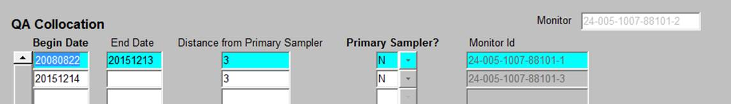

2) On Maintain Monitor Form, QA Collocation Tab, put an end date on the collocation period for the current Primary Monitor (POC 1).

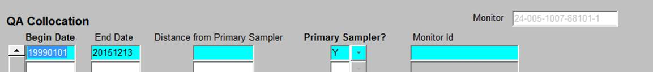

3) On the Maintain Site Form, navigate to the Primary Monitor Periods tab, and put the same end date on the Primary Monitor Period that you used in Steps 1 and 2. See the second line in the image below.

4) On the Maintain Site Form, navigate to the Primary Monitor Periods tab, and enter a new record for the Monitor you want to designate as the new Primary (POC 3).  Make the begin date ONE DAY after the end date of the previous primary monitor period. See the third line in the image below.

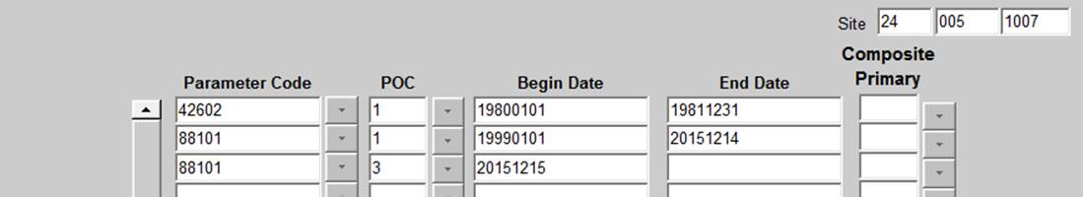

5) On Maintain Monitor Form, QA Collocation Tab, for the new Primary Monitor (POC 3), create a record with the same Begin Data you used in Step 4, and a value of “Y” in the primary sampler field.



6) Finally, On Maintain Monitor Form, QA Collocation Tab, for the Collocated Monitor (POC 2), create a record with the same Begin Data you used in Step 4, and a value of “N” in the primary sampler field.  See Line two in the illustration below (the one with no end date).

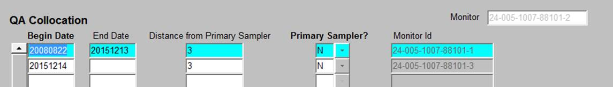

**Q.** Do we need to report blank data, and if so, how? (**Marlene Thompson)**

A. The requirements for blanks are parameter specific. For PM 2.5, they are in 40 CFR Part 50 Appendix L.

**Q.** Whom should we send new agency requests to? (**Leif Paulson**)

A. Send new agency requests to the EPA call center (help desk).

**Q.** When they make the change to ENSC file submittal to allow more than one file to be submitted at once, will you be able to do that by selecting several txt files or only by zipping the files first? (**SD DENR Barb Regynski**)

A. They will have to be zipped together.

**Q.** Do you lose certification flag if you add a QA qualifier code? (**Adam Canter**)

A. No.

**Q.** Could the AQS team provide an example of the computation of the 24-hr block average for PM10 assuming hourly values are uploaded to AQS? My own calculations following the Data Handling Conventions document are differing from AQS results in an AMP350MX report. (**Leif Paulson**):

A. This question is being answered offline with Leif sending a spreadsheet of his calculations to Nick for review. The values in question are daily 24-hr values with a midnight-to-midnight calculation. Also, just looking through our 24-hour rules for PM10, the denominator is 24 for incomplete data and not the number of samples.

**Q.** What alterations to AQS will be made for associating raw data with an exceptional event assuming the proposed EE rule is promulgated as is? (**Leif Paulson**)

A. We are not prepared to answer the EE question until the rule is final.

**Q.** I’m trying to upload lead data into AQS and we use 2 monitors for duplication only quarterly sample. Our results come from a lab and the concentration amounts have a < less then sign. Is that to be included in upload? (**Marlene Thompson**):

A. No, you'll have to find out what the lab means (probably below MDL or Non-detect) and add the correct qualifier code.

**Q.** Are the offsets something new? I don't recall filling those in, so I assume I will need to go in and add those to get completeness to calculate correctly. (**SD DENR Barb Regynski**)

A. They were implemented in 2015. See the RSS notice dated July 13, 2015.

**Q.** User is receivingError message "The system found multiple matching AQS IDs for the provided ENSC ID"...how can this be fixed? (**Cindy Wike**)

A. This problem was handled through off line correspondence with the user. Her EN ID was listed for multiple AQS IDs.

**Q.** Do we need to report Blanks Data, and how do we do it? (**Gale Koch, Marlene Thompson**)

A. Blanks data is reported via the RB transaction.