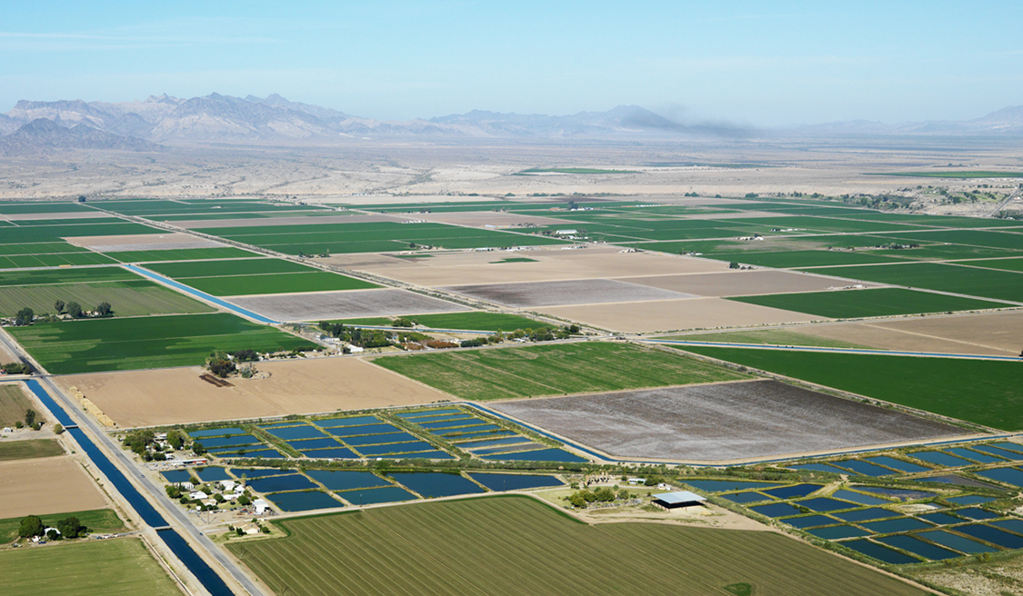
Protect against costly infrastructure failures and water outages
Support economic development in your community
Ensure that your community has safe and reliable water now and in the future
Assess the current viability of your local utilities and plan for the future

[Workshop date]

RURAL AND SMALL SYSTEMS SUSTAINABLE UTILITY MANAGEMENT WORKSHOP

Community Leaders Encouraged to Attend!
The economic strength and public health of communities across the United States depends on water systems that reliably deliver clean and safe water. Aging infrastructure, such as pipes and pumps, can fail, leading to water outages for homes and businesses, or the release of untreated sewage into homes, roads, and surface waters. Water and wastewater utilities often lack the resources needed to perform the ongoing equipment maintenance and infrastructure replacement required to ensure reliable, safe service now and into the future.
Hosting Association Name
Workshop Location
Registration Information
Help your utilities provide affordable and dependable, clean and safe water by attending this powerful, highly regarded workshop and make your water systems a community priority. Learn from workshop leaders and other utilities about how to address the challenges of today while planning for the future to improve utility success over time and bring real benefits to your community.

WHAT CAN I DO TO HELP?
- Attend a Rural and Small Systems Sustainable Utility Management Workshop with your utility mangers
- Encourage fellow community leaders to attend a Rural and Small Systems Sustainable Utility Management Workshop
- Talk to your utility leaders about the challenges that they are facing, and work together to put a plan in place for tackling those challenges
- Work through the Rural and Small Systems Sustainable Utility Management materials as a team exercise with community leaders and utility managers (a template for a “team exercise” workshop is available in USDA and EPA’s Workshop in a Box – links to this material can be found in the section below)
- Make water a priority. Water is the lifeblood of any healthy community. Without clean and safe water, no community can survive, and without the support of its community leaders, no water utility can survive.

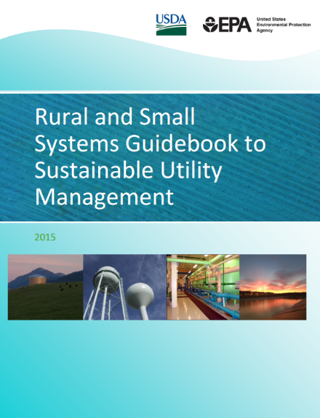
WHAT RESOURCES ARE AVAILABLE?
The Environmental Protection Agency (EPA) and United States Department of Agriculture (USDA) have worked with utilities, water associations, and technical assistance providers to create materials that help utilities address challenges and capture improvement opportunities. These materials include the Rural and Small Systems Guidebook to Sustainable Utility Management and the Workshop in a Box. You can find these resources on USDA and EPA’s websites, and you can access them through your local technical assistance providers.
http://water.epa.gov/infrastructure/sustain/watereum.cfm
http://www.rd.usda.gov/programs-services/services/sustainable-management-tools
Ten Key Management Areas
The workshops and Guidebook are built around ten key management areas. These ten areas of sustainable utility management help utility and community leaders assess utility health, discuss potential community impacts, and prioritize future activities based on what is best for the utility and the community.
- Financial Viability | - Infrastructure Stability
- Operational Resiliency | - Product Quality
- Employee and Leadership Development | - Customer Satisfaction
- Water Resource Adequacy | - Stakeholder Understanding and Support
- Community Sustainability and Economic Development | - Operational Optimization

