DRINKING WATER ADVISORY – EVERYONE

TWITTER
■ “Drinking water advisory! Do Not Drink tap water in [location]. For more information see: [insert website link]”
■ “Drinking water advisory! Residents in [location] should not drink their tap water. For more information visit: [insert website link]”
■ “Drinking water advisory! Drinking water contains potentially harmful levels of cyanotoxins. Do Not Drink tap water in [location]. See: [insert website link]”
■ “Residents in [location] should not drink their tap water. For more information visit: [insert website link]”
■ “Residents should temporarily avoid drinking tap water in [location] until further notice. For more information visit: [insert website link]”

FACEBOOK
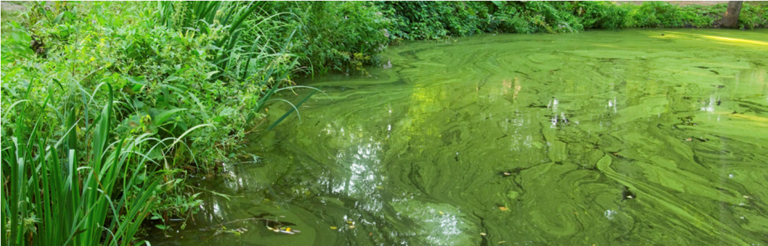
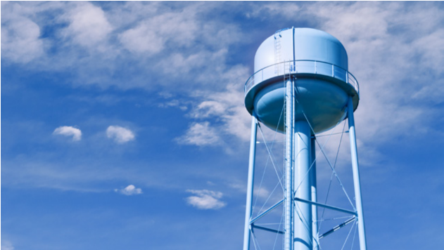
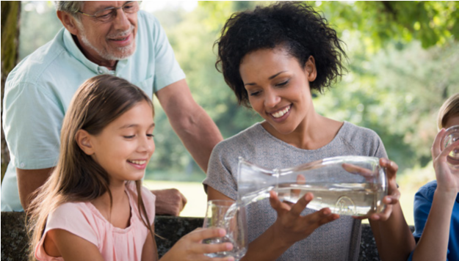
■ “Drinking water advisory! Cyanotoxins were detected in [location]’s tap water exceeding the national drinking water Health Advisories. Therefore, residents in the affected areas should not drink the water.
SOCIAL MEDIA
■ Do Not Drink the tap water. [Alternative sources of water] should be used for drinking, making infant formula, making ice and preparing food and beverages.
■ Do Not Boil the tap water. Boiling the tap water will not destroy cyanotoxin and may increase toxin levels.
■ Everyone may use tap water for showering, bathing, washing hands, washing dishes, flushing toilets, cleaning and doing laundry. However, infants and young children under the age of six should be supervised while bathing and during other tap water-related activities to prevent accidental ingestion of water.
■ Drinking water containing cyanotoxins at levels exceeding the national drinking water Health Advisories puts you at risk of experiencing adverse health effects of cyanotoxins. Possible adverse health effects include upset stomach, vomiting and diarrhea as well as liver and kidney damage. Seek medical attention if you or your family members are experiencing illness.
■ Cyanotoxins can be harmful to animals. Consider alternative water sources for animals. Contact a veterinarian if animals show signs of illness.
■ [System name] will be taking the following actions to reduce contaminant levels as soon as possible: [list actions].
■ [System name] will post an updated advisory when: the [cyanotoxin] levels are less than or equal to the U.S. Environmental Protection Agency’s national Health Advisories, this Do Not Drink Advisory is lifted, and/or if there are any changes to the conditions of this Do Not Drink Advisory.
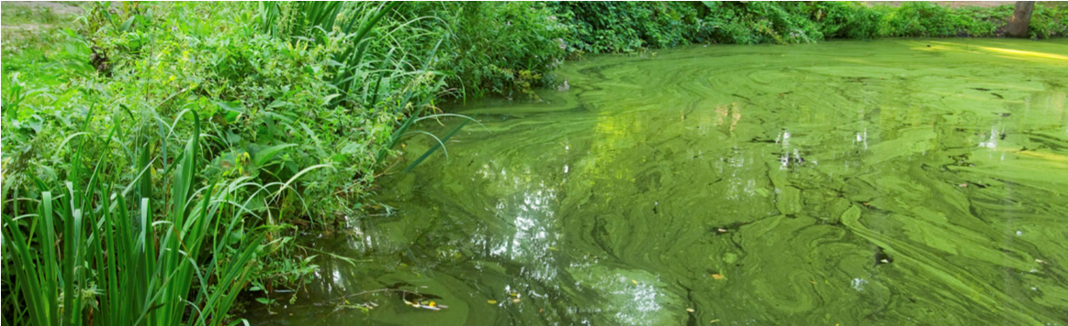
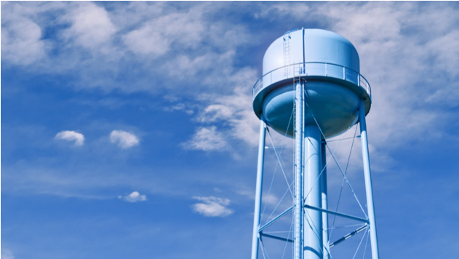
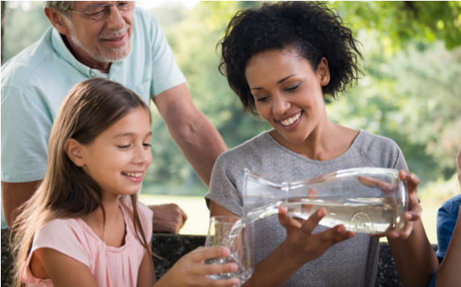
■ For additional information: [insert website link].
SOCIAL MEDIA

AUTOMATED TEXT MESSAGES
■ “Drinking water advisory! [Location’s] tap water contains [cyanotoxin name] at potentially harmful levels. All residents - Do Not Drink the tap water until further notice. Do Not Boil tap water. Please see [insert website link] or call [insert phone number] for more information.”
■ Wireless Emergency Alert message: “Drinking water advisory! Do Not Drink or boil the tap water.”

