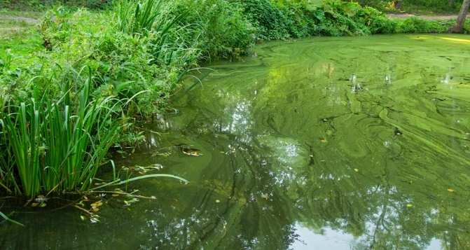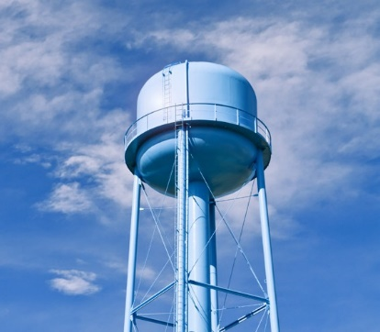
PUBLIC MESSAGING

SUMMARY—KEY MESSAGES
- Cyanobacteria, formerly known as blue-green algae, naturally occur in surface waters. Under certain conditions, such as in warm water containing an abundance of nutrients, they can rapidly form harmful algal blooms (HABs). Some of these blooms are capable of producing toxins known as cyanotoxins that can harm humans and animals.
- Conventional water treatment (consisting of coagulation, sedimentation, filtration and chlorination) can generally remove intact
cyanobacterial cells and low levels of toxins. However, water systems may face challenges providing drinking water during a severe bloom event when drinking water sources contain high levels of cyanobacteria and cyanotoxins.
- Cyanotoxins are capable of harming humans. Given the potential health risks they pose, national drinking water Health Advisories were developed by the U.S. Environmental Protection Agency for the cyanotoxins microcystins and cylindrospermopsin.
- Many water systems are taking actions to manage and reduce the risks from cyanotoxin contamination in drinking water. These actions may include steps for cyanotoxins monitoring, adjusting treatment to address contamination before levels are of concern and notifying the public if there are cyanotoxins at levels of concern in their tap water through public communication and Drinking Water Advisories.
- Reducing nutrient pollution, such as nitrogen and phosphorus, in drinking water sources is important for the long-term management of the risks HABs pose to public health and water quality.

DETAILED MESSAGES

Cyanotoxins and drinking water
- Cyanobacteria, formerly known as blue-green algae, naturally occur in surface waters. Under certain conditions, such as in warm water containing an abundance of nutrients, they can rapidly form harmful algal blooms (HABs). These blooms are capable of producing toxins known as cyanotoxins.
- Conventional water treatment (consisting of coagulation, sedimentation, filtration and chlorination) can generally remove intact
cyanobacterial cells and low levels of toxins. However, water systems may face challenges in providing drinking water during a severe bloom event, when there are high levels of cyanobacteria and cyanotoxins in drinking water sources.
- A water system may elect to issue a drinking water advisory if cyanotoxin levels exceed the U.S. Environmental Protection Agency Health Advisories, or a local- or state- determined limit, after the appropriate number of confirmation samples have been taken.
- If a drinking water advisory is issued, follow the recommendations described in the advisory notification.
- During the advisory, your public water system will be treating your drinking water to reduce the levels of toxins as soon as possible.
- Before the advisory is lifted, follow-up samples of tap water will be taken to ensure the cyanotoxin levels are less than or equal to the national drinking water

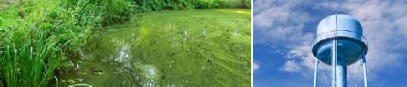

PUBLIC MESSAGING

Health Advisories or a local- or state- determined limit.
[Insert any additional system-specific activities here].

Human health impacts
  - Some harmful algal blooms can produce cyanotoxins that can be harmful to human and animal health.
  - Drinking water containing [cyanotoxin name] at levels exceeding the U.S. Environmental Protection Agency’s national drinking water Health Advisories can put you at risk of various adverse health effects including upset stomach, vomiting and diarrhea as well as liver and kidney damage. Seek medical attention if you or your family members are experiencing illness. Consumers who may be vulnerable to the health risks from lower cyanotoxin levels include infants and young children under the age of six, pregnant women, nursing mothers, those with pre-existing liver conditions, those receiving dialysis treatment, the elderly and other sensitive populations.
  - Human and animal illnesses associated with cyanotoxin exposure can be reported to state or local health departments who report the information to the Centers for Disease Control and Prevention (CDC) to better understand cyanotoxin-associated illnesses. To learn more about harmful algal bloom- associated illnesses, visit www.cdc.gov/habs.

Health Advisories
  - The U.S. Environmental Protection Agency (U.S. EPA) developed national drinking water Health Advisories for the cyanotoxins microcystins and cylindrospermopsin (see Table 1). If levels found in drinking water are above those recommended in the Health Advisories, public water systems may elect to issue a Drinking Water Advisory that can provide guidance such as “Do Not Drink and Do Not Boil.”
  - Public water systems are not required by federal law to issue Drinking Water Advisories, however, in some cases, states may require actions by water systems.
  - The Health Advisory levels for microcystins and cylindrospermopsin are non-regulatory
concentrations of drinking water contaminants at

which adverse health effects are not anticipated to occur over a 10-day exposure period. Because it is difficult to determine in advance the duration of elevated algal toxin levels, the U.S. EPA recommends that water systems begin to take actions once the elevated levels have been confirmed by additional samples. Additionally, because of time needed to process sequential analytical tests, it can take several days following
the detection of a bloom and/or cyanotoxins before concentrations above the Health Advisory values are confirmed in finished tap water. Therefore, the U.S. EPA recommends initiating the response activities as soon as practicable.
- For each of the cyanotoxins, the U.S. EPA developed Health Advisories for two distinct populations. These populations are: 1) Infants and young children under the age of six and 2) Children six years and older and adults.
- Two different Health Advisory levels were developed because infants and young children under the age of six consume more water relative to their body weight as compared to adults and children six years and older. Therefore, the Health Advisory numbers are lower for infants and young children under the age of six than for older children and adults.
- In addition to infants and young children under the age of six, other vulnerable populations such as pregnant women and nursing mothers, the elderly,

10-DAY HEALTH ADVISORIES | LEVEL
Microcystins
Children pre-school age and younger (under 6 years old) | 0.3 µg/L
School-age children (6 years and older) | 1.6 µg/L
Cylindrospermopsin
Children pre-school age and younger (under 6 years old) | 0.7 µg/L
School-age children (6 years and older) | 3.0 µg/L
Table 1. U.S. EPA’s National 10-Day Health Advisories

PUBLIC MESSAGING

those with pre-existing liver conditions, those receiving dialysis treatment and other sensitive populations may be vulnerable to the health effects of cyanotoxins at lower levels. As a precautionary measure, individuals that fall into these groups should consider following the recommendations that are provided in advisories for infants and young children under the age of six.

Drinking water advisories
  - If a drinking water advisory is issued for cyanotoxins, follow the recommendations described in the advisory notification. There is a possibility that there will be different instructions for different population groups, depending on the level of cyanotoxin found in the drinking water.
  - Using the the U.S. Environmental Protection Agency’s national Health Advisory levels for microcystins and cylindrospermopsin as a guide, ranges of cyanotoxin levels in drinking water can be shown with the following advisory levels: green, yellow and red (see Figure 1). Green corresponds
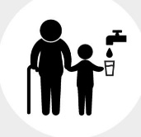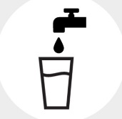
Drinking Water Health Advisories
ADVISORY LEVEL
Cyanotoxins not
detected in tap water
at levels of concern.
Cyanotoxins detected
in tap water at levels
of concern for young
children and vulnerable
populations.*
Cyanotoxins detected
in tap water at levels
of concern.
ACTION
*vulnerable populations = infants, children under the age of six, pregnant
women, nursing mothers, those with pre-existing liver conditions, those
receiving dialysis treatment, the elderly and sensitive populations.
Figure 1. Drinking Water Health Advisories

to a drinking water toxin levels where adverse health impacts are unlikely to occur for everyone, the yellow range indicates drinking water toxin levels where the risk of adverse health impacts is higher for infants, young children under the age of six and other vulnerable populations, while the red range indicates drinking water toxin levels above the guidelines where the risk of adverse health impacts is higher for everyone drinking the water. Drinking water systems could elect to issue Drinking Water Advisories using these categories as guides.
- If the cyanotoxin level has exceeded the Health Advisory level for vulnerable populations (including infants and young children), but not the level for older children through adults, possible Drinking Water Advisory instructions may include:

The following vulnerable populations should not drink the tap water: infants, young children under the age of six, pregnant women,
nursing mothers, those with pre-existing liver conditions and those receiving dialysis treatment. As a precautionary measure, the
elderly and other sensitive populations should consider following these advisory instructions. You should use [alternative sources] for drinking water, making infant formula, making ice and preparing food and beverages.
- Do Not Boil the tap water. Boiling the water will not destroy cyanotoxins and may increase the toxin levels.
- Individuals not considered to be in the vulnerable category, as listed above, may drink the tap water.
- Everyone may use tap water for showering, bathing, washing hands, washing dishes, flushing toilets, cleaning and doing laundry. However, infants and young children under the age of six should be supervised while bathing and during other tap water-related activities to prevent accidental ingestion of water.
- Adverse health effects of toxin exposure at levels above the national drinking water Health

PUBLIC MESSAGING

Advisories may include: upset stomach, vomiting and diarrhea as well as liver and kidney damage. Seek medical attention if you or your family members are experiencing illness.
  - [Water system] will be taking the following actions to reduce the contaminant levels as soon as possible: [list actions].
  - [Water system] will post an updated advisory when: the [cyanotoxin] levels are less than or equal to the U.S. Environmental Protection Agency’s national Health Advisories or a local- or state-determined limit, this Do Not Drink Advisory is lifted and/or if there are any changes to the conditions of this Do Not Drink Advisory.
  - If the cyanotoxin level has exceeded the Health Advisory level for vulnerable populations (including infants and young children) and for older children through adults, possible Drinking Water Advisory instructions may include:
    - Do Not Drink the tap water. [Alternative sources of water] should be used for drinking, making infant formula, making ice and preparing food and beverages.
    - Do Not Boil the tap water. Boiling the water will not destroy cyanotoxin and may increase toxin levels.
    - Everyone may use tap water for showering, bathing, washing hands, washing dishes, flushing toilets, cleaning and doing laundry. However, infants and young children under the age of six should be supervised while bathing and during other tap water-related activities to prevent accidental ingestion of water.
    - Adverse health effects of toxin exposure at levels above the national drinking water Health Advisories may include: upset stomach, vomiting and diarrhea as well as liver and kidney damage. Seek medical attention if you or your family members are experiencing illness.

- Consider alternative sources of drinking water for animals. Contact a veterinarian if animals show signs of illness.
- Drinking water systems will be taking the following actions to eliminate the contaminant as soon as possible: [list actions].
- [Water system] will post an updated advisory when: the [cyanotoxin] levels are less than or equal to the U.S. Environmental Protection Agency’s national Health Advisories or a local- or state-determined limit, the Do Not Drink Advisory is lifted and/or if there are any changes to the
conditions of the Do Not Drink Advisory.

Preventing harmful algal blooms and their toxins in the long run
- Keeping [lake/river] that supplies our drinking water clean is key to preventing algal blooms and their cyanotoxins from impacting drinking water.
- Preventing and reducing nutrient pollution, such as excess nitrogen and phosphorus, through source water protection activities is important for managing risks associated with harmful algal blooms in drinking water.
- Residents can help by engaging in everyday activities that decrease nutrient pollution in our drinking water sources:
- Use phosphate-free detergents

- Dispose of your pet waste properly

- Apply fertilizers only when necessary and at the recommended amount
- Volunteer in local watershed protection efforts

- Additional prevention activities can be found at https://www.epa.gov/nutrientpollution/what-you- can-do.

