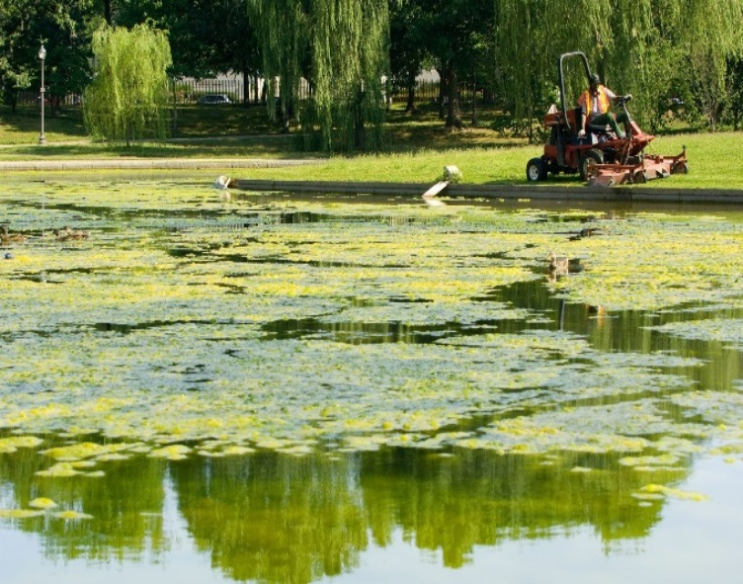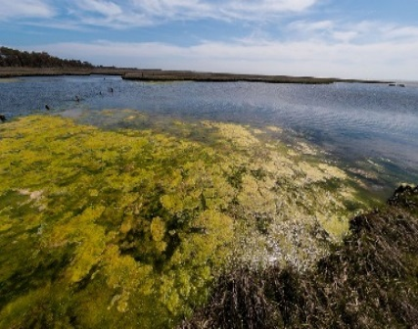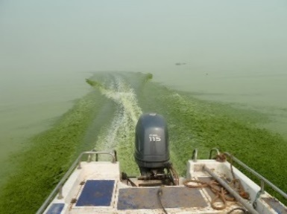
PRESS RELEASE
RECREATIONAL WATER CLOSURE ISSUED
FOR IMMEDIATE RELEASE
Media Contact: [insert name, title, telephone and fax number, and e-mail of spokesperson]
WHY IS THERE A CLOSURE?
- [Cyanotoxin or cyanobacteria name], a toxin produced by cyanobacteria (formerly known as blue-green algae) was detected in the water at levels that could cause harm at [location] on [date].
- Samples collected on [dates] show [cyanotoxins or cyanobacteria name] in [location] at [levels and/or ranges], which are above the state-designated recreational water health advisory levels.
WHAT SHOULD I DO?
- Do not swim, wade or come in contact with the water, scum, foam or algae at [location].
- Seek medical attention if you or family members are experiencing illness after swimming or playing in water. Recreational waters containing [cyanotoxin or cyanobacteria name] at levels exceeding the state’s guidelines for issuing a Health Advisory can put you at risk of various adverse health effects including upset stomach, vomiting and diarrhea. Exposure to concentrations of cyanotoxins higher than the state’s guideline values could potentially result in more serious illnesses, including liver or kidney damage.
- Animals may be vulnerable to adverse health effects of [cyanotoxin or cyanobacteria name] at the detected levels indicated above. Contact a veterinarian if animals show signs of illness.
- If you, your family members or your animals have experienced adverse [cyanotoxin- or cyanobacteria-related] health effects, please contact [State or local Health Department] to report the illness.
WHAT IS BEING DONE?
- [Organization name] is working closely with local and state public health and emergency response agencies to address the situation.
- [Organization name] will post updated information when: the [cyanotoxin or cyanobacteria] levels are less than or equal to the State’s Health Advisory levels, the Advisory is lifted or if there are any changes to the conditions of this recreational closure.
For more information, please contact [contact information] or visit [website]. Please share this information with other people who recreate in these waters, especially those who may not have received this notice directly.

This notice is being sent to you by [Organization name].Telephone Number [000-000-0000]
Address [Street, City, State 00000] [www.URL.com]

