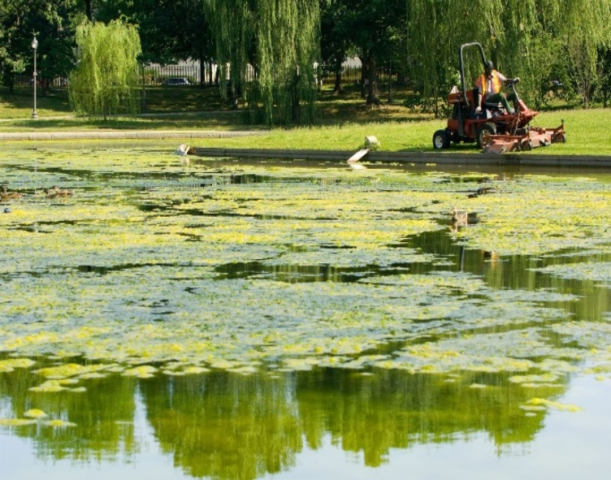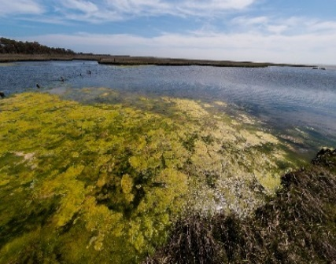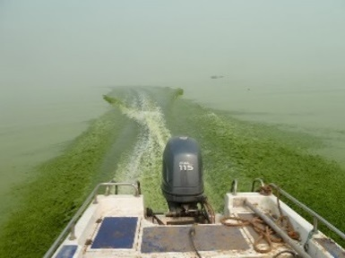
PRESS RELEASE
RECREATIONAL WATER CLOSURE LIFTED
FOR IMMEDIATE RELEASE
Media Contact: [insert name, title, telephone and fax number, and e-mail of spokesperson]

[Organization name] LIFTS THE RECREATIONAL CLOSURE FOR [CYANOTOXIN NAME] AT [LOCATION] – SAFE FOR SWIMMING

[LOCATION] [Month Date, Year] – Officials from [organization name] lifted the recreational water advisory in [area affected] issued on [date]. Water quality samples collected on [dates] showed [cyanotoxin or cyanobacteria name], a toxin produced by cyanobacteria (formerly known as blue-green algae), detected at [levels and/or ranges] on [dates]. This level is [less than or equal to] the state-designated recreational water health advisory levels for [cyanotoxin or cyanobacteria level]. Residents may resume recreating at [location].
[Cyanotoxin or cyanobacteria name] was detected at [levels and/or ranges] on [dates], exceeding the state-designated recreational water health advisory levels that is set at [level]. A recreational closure was in place for [number of days]. The [organization name] quickly [posted/closed] the [location] in response to levels of [cyanotoxin or cyanobacteria name]. Samples collected on [dates] show [cyanotoxin or cyanobacteria name] levels are now [less than or equal to] the state-designated recreational water health advisory levels and residents may resume recreational activities in this water. [Insert any actions taken to reduce risks of cyanotoxins in the future].
[Insert quote here from local official]
Anyone wanting additional information about this event is encouraged to contact [name of person] at [contact information] and/or consult the following website for relevant information: [link to lifted advisory notification].

This notice is being sent to you by [Organization name].
Telephone Number [000-000-0000]
[123 Address Street, City, State 00000]
[www.URL.com]

