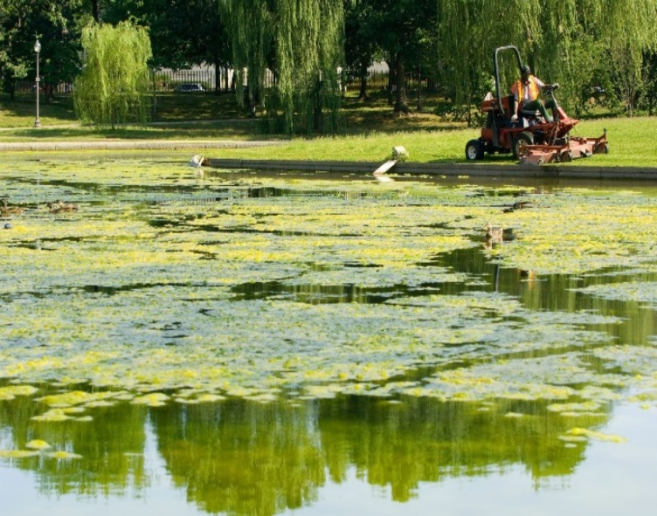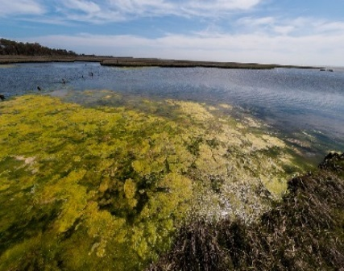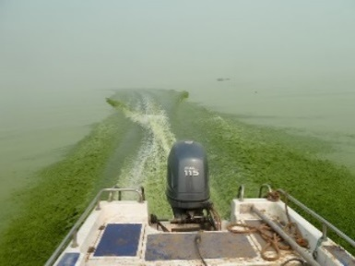
SOCIAL MEDIA
RECREATIONAL WATER ADVISORY or CLOSURE ISSUED

TWITTER
- “WARNING—Water Contact Might Cause Illness. The water at [location] contains [cyanotoxins or cyanobacteria] at levels that could cause harm. Do not swim. For more information, see: [insert website link]”
- “[Location] is closed. The water at [location] contains [cyanotoxins or cyanobacteria] at levels that could cause harm. Avoid all contact with the water, scum, foam or algae. For more information, see: [insert website link]”

FACEBOOK

- “WARNING- [cyanotoxins or cyanobacteria] have been measured at [location] and could cause harm.”

- “[Location] is contaminated with [cyanotoxins or cyanobacteria]. Water samples were tested on [dates] for [cyanotoxin or cyanobacteria name] and show levels that may cause harm. People, pets and livestock should avoid any contact with the water, scum, foam or algae. For additional information: [insert website link]”

AUTOMATED TEXT MESSAGES
- “Advisory has been posted for [location]. Levels of [cyanotoxins or cyanobacteria] at potentially harmful levels. People, pets and livestock should avoid contact with the water. For additional information, please see [website link].”
- “Wireless Emergency Alert message: “[Location] is closed due to [cyanotoxins or cyanobacteria] that may harm people, pets or livestock. For additional information, please see [website link] or tune into [radio / TV station].”

