Sample Workshop Invitation
This sample agenda was developed as part of the U.S. Environmental Protection Agency’s Local Foods, Local Places Toolkit: A Guide to Help Communities Revitalize Using Local Food Systems. The complete toolkit is available at https://www.epa.gov/smartgrowth/local-foods-local-places-toolkit.
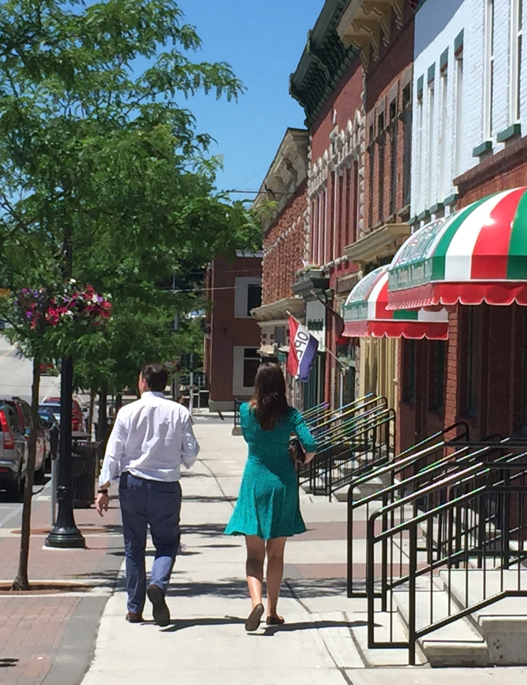
You are invited to a series of
Local Foods, Local Places
Community Planning Events
[Insert Day], [Insert Date], [Insert Time] and
[Insert Day], [Insert Date], [Insert Time]
[Insert Location]
Who: Stakeholders and community leaders such as you, interested in making Canton a more livable, healthy, vibrant, and engaged community through the building and strengthening your local food economy. Participants include representatives from community agencies, organizations, elected officials, residents, and facilitators.
What: A participatory planning process on local foods and community livability in Canton, including group work sessions and networking that will result in an action plan. The 1.5-day process will include the following topics:
- Sharing information about the projects currently underway to revitalize downtown Canton and grow the local food system.
- Identifying the strengths and weaknesses of the Canton local food system and other aspects of community life.
- Revitalizing downtown through expansion of the local food network.
- Connecting the local food network with pedestrian trails and other transportation facilities.
- Generating consensus on goals that could be accomplished within the next two years.
Background: In 2014, a group of residents and business owners in the Village of Canton got together and decided to develop an action plan that leverages the budding success of the local food scene to help revitalize downtown Canton and maximize its economic potential. A team of expert facilitators will join local stakeholders like you in a 1.5-day workshop to develop an action plan to better tie together the resources we have, identify the major missing pieces, and bridge gaps. We will work to prioritize next steps and identify roles, responsibilities, and resources to move forward. Your participation and knowledge of Canton’s local food system, culture, and economy are necessary to help make this event a success.
Website for RSVP: [insert link]
For more information, contact: [insert contact information]

