Creating a regular grid for use with BenMAP
The below instructions assume that you have a data set with point coordinates (assumed to be centroids here) and some values that you need to assign to a grid.
Step 1: Identify the projection used to create the centroids of the grid you are trying to create. This is important, because without this information (or at least an informed guess), you will discover that your points do not end up exactly where you think they should be in the resulting grid. Some may be close to the center, while others may drift away from the center.
Step 2: In a new blank map in ArcGIS, set the data frame coordinate system to the projection used for your point data. In this example, the points use the USA Contiguous Lambert Conformal Conic projection.
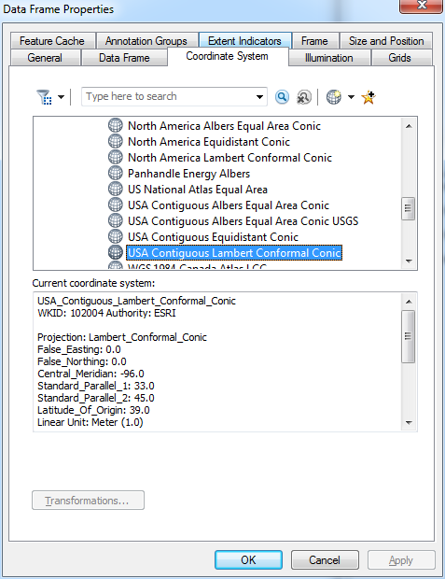

Step 3: Identify the maximum and minimum X and Y values from your point data, as well as the distance between the points. In the “natGrid.pred.4yrs.csv” data used for this example:
X Minimum: -2336.321542 km
X Maximum: 2238.678458 km

Y Minimum: -1467.691991 km
Y Maximum: 1382.308009 km

Distance between points: 25 km

Step 4: Now you have enough information to calculate the bounds of the grid. Still assuming the points are the centroids, add 12.5 km in each direction to get the full domain of the grid. That is:

X Minimum: -2336.321542 km - 12.5 km = -2348.821542 km
X Maximum: 2238.678458 km + 12.5 km = 2251.178458 km

Y Minimum: -1467.691991 km - 12.5 km = -1480.191991 km
Y Maximum: 1382.308009 km + 12.5 km = 1394.808009 km

Step 5: Now you can create the actual grid using either the XTools fishnet tool or the built-in ArcGIS fishnet tool. Using XTools, open the fishnet tool and enter the values into the form. The extent is custom, and uses the values that were calculated in Step 4, converted to meters. In this case, the cell shape is rectangular, and the size is specified as 25,000 m. XTools will add column and row index variables if desired, and the below setting numbers the cells CMAQ-style, starting in the lower left-hand corner.
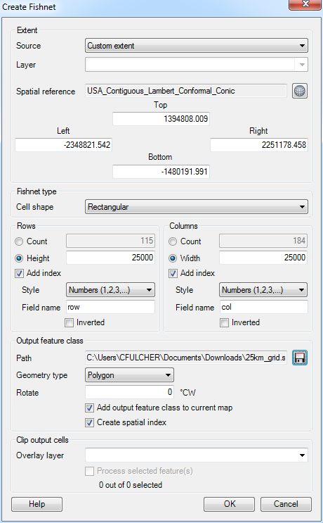
You can also do this with the ArcGIS fishnet tool in ArcToolbox, though it requires some post-processing to assign the column and row variables.

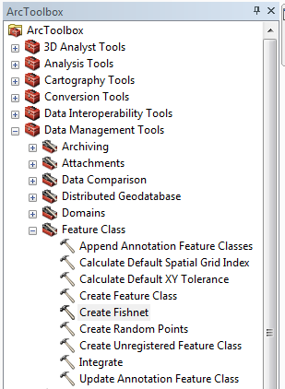

Enter the same domain as in XTools, specify the cell size, and verify that the output is set to POLYGON.

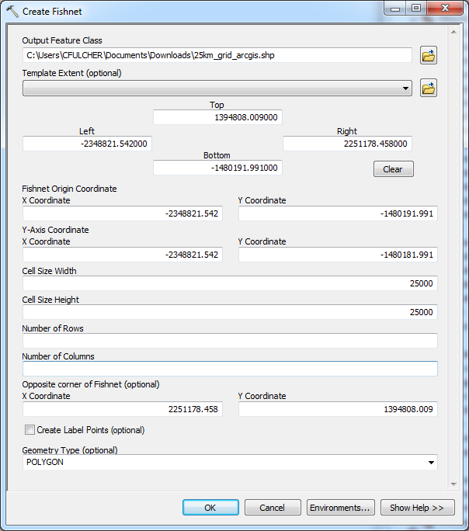

Open the attribute table of the resulting shapefile, and add fields for X, Y, column and row. The X and Y fields should be defined as double, while the col and row fields should probably be set to long integer to be safe.

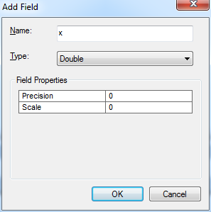

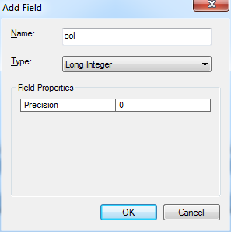

You calculate the X and Y values by right clicking on the X (or Y) field and selecting “Calculate Geometry…” from the dropdown menu. Select “X Coordinate of Centroid” under property and click OK. Repeat this for the Y field, selecting the “Y Coordinate of Centroid” in that case.

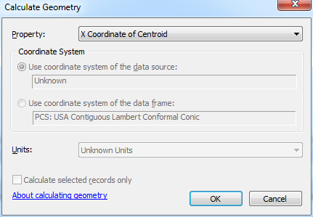

Now you can use the X and Y coordinates to assign a row and column value. Remember that BenMAP requires positive integer values for column and row. These can be calculated using a little algebra. Using the minimum X and Y values of the point data (Step 3), divide the minimum values by the grid cell size (25 km), and calculate the amount that must be added to this value so that the value becomes 1. In this case, (-2336.321542/25) = -93.45286168 and (-1467.691991/25) = -58.70676964, so the column and row values are calculated in the field calculator as

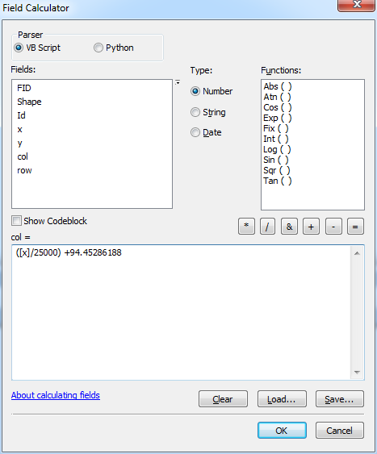

and

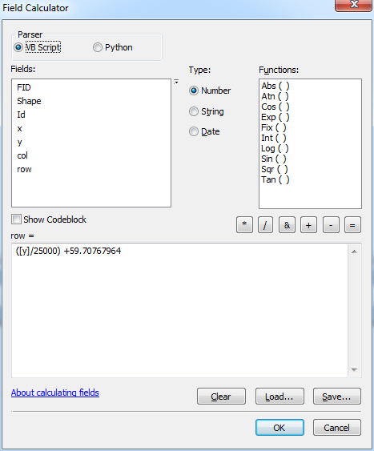.

Now you can plot your original points on the resulting grids and verify that the points are inside the grids as expected. In the data used for this example, the X and Y are in km while ArcGIS expects meters, so those fields will not produce the expected results. However, the latitude and longitude are also provided in the data, and using these to create XY events leads to the following results.

Using XTools generated grid:
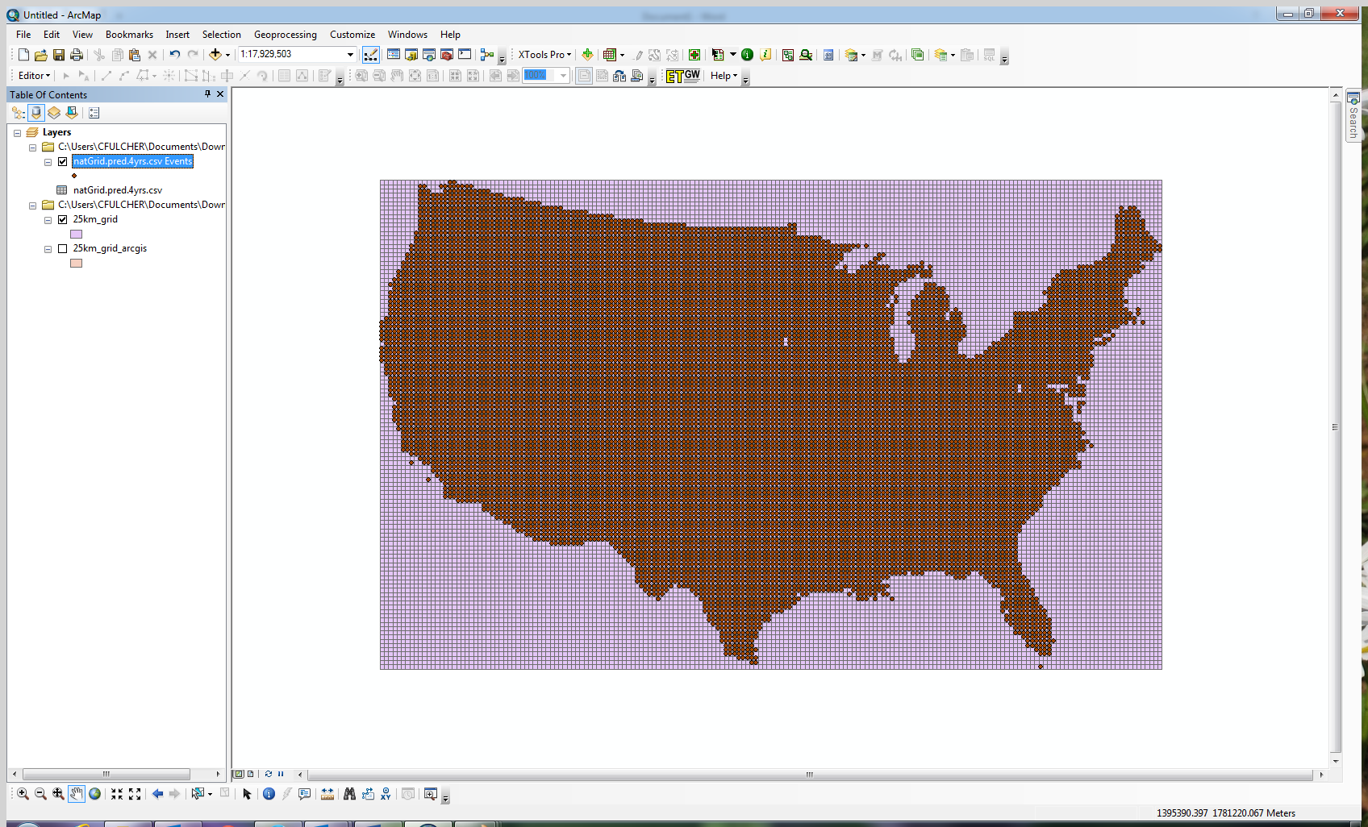

Using ArcGIS generated grid:
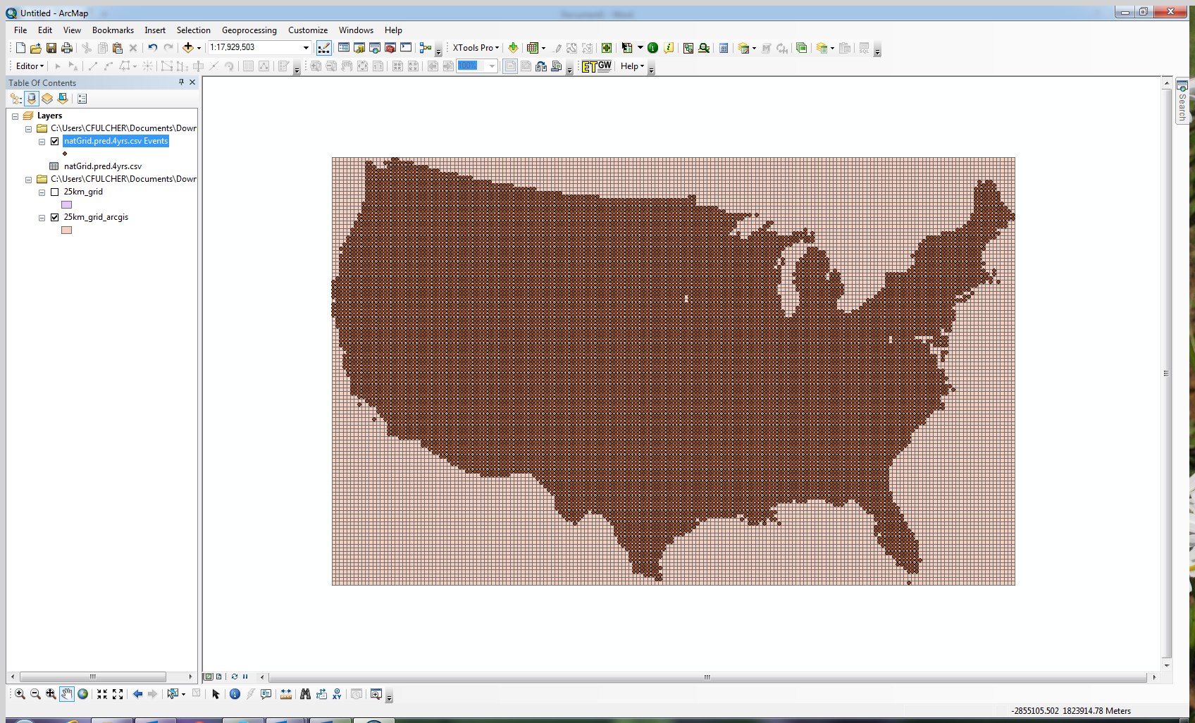

Step 6: The grid should be projected into NAD83 (or WGS84) for use in BenMAP, using the Projection tool in ArcToolbox. Also, you would at this point still need to assign the column and row values to any data that you will be using with this grid. This can be accomplished using similar algebra as was employed above, or by doing a spatial join of the grid to the points.

