Sample WIFIA Social Media
Note: These messages have been approved by OPA. Please feel free to issue these messages from EPA social media accounts or provide to stakeholders to use.
Prospective borrowers seeking #WIFIA credit assistance now have until July 31, 2018, to submit a letter of interest. Learn more and prepare letters of interest at: www.epa.gov/WIFIA #waterinfrastructure #TimeToBuild
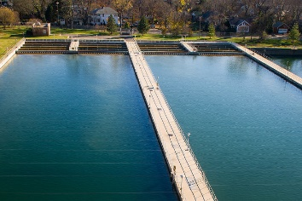
#WIFIA funding has the potential to improve vital #waterinfrastructure. The deadline to submit a letter of interest has been extended to July 31st. Learn more: https://www.epa.gov/newsreleases/epa-extends-deadline-apply-wifia-water-infrastructure-loan #TimeToBuild
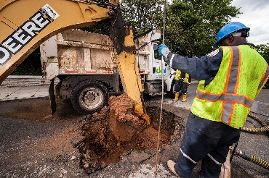
This year’s #WIFIA Notice of Funding Availability highlights the importance of #lead service line replacement and upgrading aging #waterinfrastructure. Deadline to submit a letter of interest is July 31. Learn more and prepare letters of interest at: www.epa.gov/WIFIA #TimeToBuild #GetTheLeadOut
In the market for a #waterinfrastructure loan? Consider applying for credit assistance from WIFIA! Deadline to apply is July 31, 2018. Learn more here: https://www.epa.gov/wifia
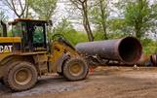
@KingCountyWA received our first #WIFIA loan to help finance its #waterinfrastructure upgrades. More funding is now available. Submit your letters of interest by 7/31: https://www.epa.gov/wifia
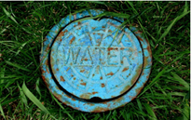
EPA’s #WIFIA program has funding available to provide as much as $5.5 billion in water infrastructure loans now. Letters of interest are due 7/31. https://www.epa.gov/wifia
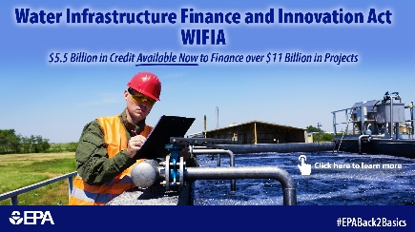
Applying to #WIFIA for a #waterinfrastructure loan? Use our new checklist for submitting a successful letter of interest: https://www.epa.gov/wifia/how-apply-wifia-assistance-0
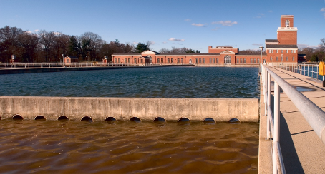
Need help with applying for a #WIFIA #waterinfrastructure loan? Check out our sample letter of interest, summary financial pro forma template, frequent questions, and more! https://www.epa.gov/wifia/how-apply-wifia-assistance-0.
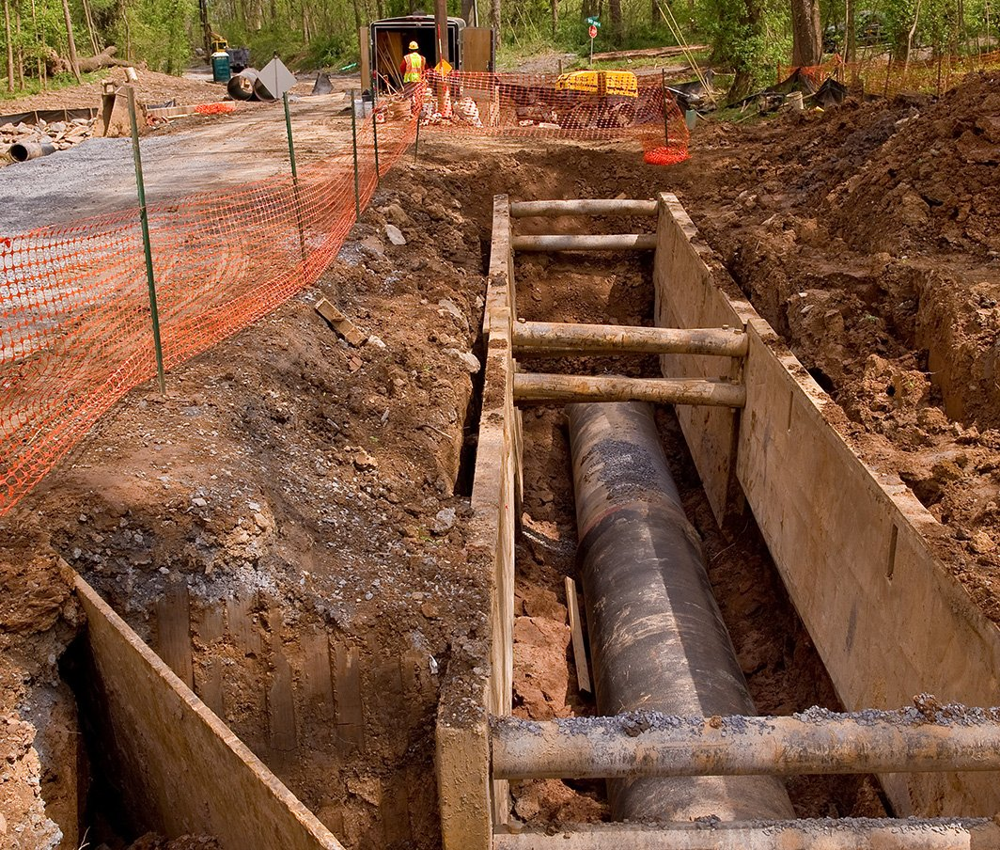
Get your questions about the #WIFIA letter of interest submission and selection process answered. Register for the webinar on 5/30 at 2pm EDT. https://register.gotowebinar.com/register/2373993328733523203 #waterinfrastructure
