GAP Success Stories.
Instructions and Optional Template

Using the Template
Fill out the GAP success story template below by submitting responses to the prompts and adding photos.
- To replace any placeholder text with your own, just select it and start typing – OR – start typing your own text below the placeholder text and then delete the placeholder text once you are done with that section.
- To replace a picture in the template, simply right-click on the photo to access the Change Picture command – OR – select a picture and then, on the Picture Tools Format tab in the Adjust group, click Change Picture.
Topics to Consider
Highlight a significant accomplishment of your GAP program that has achieved greater environmental and/or public health protection for your community and/or region. Following are a few examples of successes t0 consider. Other topics are also welcome.
- The tribe has established community outreach and education programs to address an environmental concern/issue.
- The tribe developed and implemented an EPA-Tribal Environmental Plan (ETEP) and used it to make progress toward achieving one or more tribal goals.
- The tribe has passed laws, codes, and/or regulations with compliance assurance and enforcement provisions.
- The tribe has established intergovernmental partnerships (e.g., MOUs, interagency agreements) with federal, state, local and/or tribal governments to address environmental issues.
- The tribe has used GAP funding to develop capacity to establish other EPA programs (e.g., CWA 106, Brownfields, or CAA 103/105).

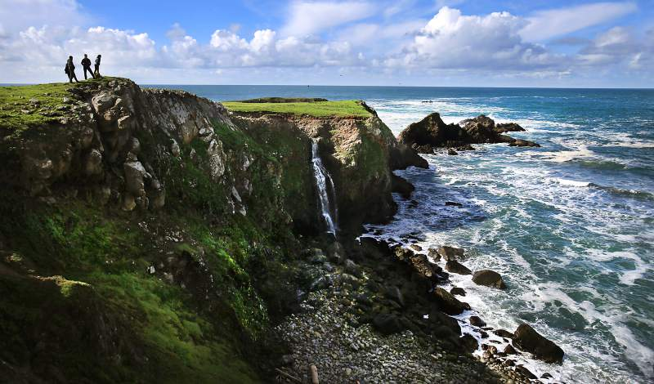  Project Title (This is the title of the success story. It should be a concise summary of the project. Try to avoid acronyms and jargon.) |  | - Project Time Period  - (FY20XX– FY20XX)  - Tribal Contact: name of Environmental Director or relevant staff person  - GAP Project Officer: name of GAP PO at US-EPA  - Media: [Air, Water, Solid Waste, USTs, CERCLA, FIFRA, TSCA, etc.]  - GAP Funded Results:  [Place an X on all that apply]  Consultation & Coordination  ETEP Development/Implementation  Outreach and Education  Program Development (Core Competencies)  TAS (or similar) application process  Training
Name of Tribe |  | City, State

Project Description
Brief description of the project (1-2 paragraphs), including answers to the following: what did the project accomplish? Include any data or numbers that illustrate the size and scope of the project. How did the project expand the tribe’s environmental capacity? What “indicators” from the GAP Guidebook did the project either complete or move the tribe closer to completion? Was the project multi-media (e.g. focusing on environmental management or including multiple EPA statutory programs) or did it focus on one particular statute (e.g. CAA, CWA, 319)?

Project Details
Describe the process of undertaking the project (1-2 paragraphs). When did the tribe begin planning this project? Did the project necessitate that staff receive additional training? Did the project include any contractors? Were any other tribal, state, local, or federal agencies involved? Were any other regional work groups, non-profits, or other groups involved?
Any large project involves challenges and hiccups along the way. Please include an example of such a challenge and how the tribe was able to overcome it. For example, a lack of existing infrastructure, personnel changes, unanticipated issues, or funding limitations.

Community Response
Briefly describe how the project has (or will) impact the community (1 paragraph). How did you measure the success of the project in the community? What was the impact on human health? How was the community engaged to participate in or learn about the project? What feedback did you get from the community that changed the current or future iterations of the project?

Innovation
Briefly describe what was new or innovative about this project (1 paragraph). Was this the first time a project like this was undertaken by the tribe? Were new tools or systems created as part of this project? Were existing tools or systems adapted to suit the community’s needs? What new and innovative elements were included in this project that make it unique?

Next Steps
Describe how the project will move forward and/or what are the remaining needs in the project’s area (1 paragraph). Was the project a stepping stone to something larger? Was the project a pilot effort that will now be evaluated and expanded? Are there remaining needs in the community that the project hopes to tackle in future years or with additional funding?
For additional info: Include a link to a tribal website, if applicable.
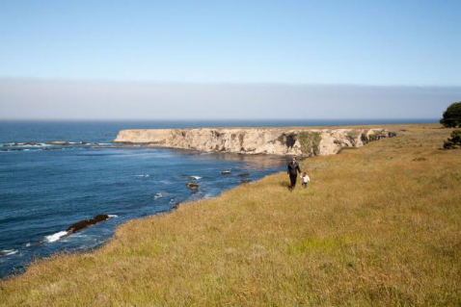
Before Photo & Description
In 2-3 sentences, describe the conditions before the project was developed. What were the environmental concerns that led to the tribe undertaking this project? What were the capacity building needs that the project was designed to address?
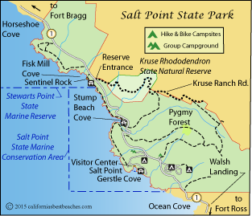
Map of Tribal Boundaries
Provide a map showing the location of the tribal lands and/or where the project was undertaken. Provide a 2-3 sentence description of the community, including details (as available) on the size of the tribe’s land base, the number of community members, and any relevant natural resource issues that led to the project.

