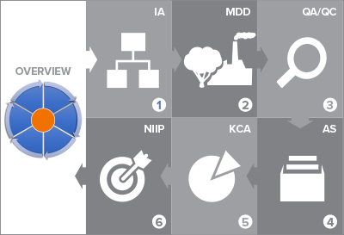

# U.S. EPA Templates for Creating a National GHG Inventory System Manual

# How to Use the Templates

|  |  |
| --- | --- |
| cid:image024.png@01D38A00.13C00220 | **1: How to Use the Templates** |
|  | **2: Institutional Arrangements** |
|  | **3: Methods and Data Documentation** |
|  | **4: QA/QC Procedures** |
|  | **5: Key Category Analysis** |
|  | **6: Archiving System** |
|  | **7: National Inventory Improvement Plan** |

Staff member responsible for populating the template - Contact Information

|  |  |  |  |
| --- | --- | --- | --- |
| Name: |  | Organization name: |  |
| Title/Position: |  | Organization postal address: |  |
| Phone number: |  | Organization web address: |  |
| Email: |  | Organization phone number: |  |

## Introduction to Template 1. How to Use the Templates

In the U.S. EPA's Templates for Creating a National GHG Inventory System Manual, this is Template 1. Its purpose is to explain how to use the template series, and provide a table in which to track progress with completing the other templates in the series. The template provides the National GHG Inventory Coordinator (NIC) with a table in which to record due dates for key compilation stages,[1] and an overarching inventory schedule can help initiate and drive planning. This template can facilitate inventory planning steps for current (e.g., Biennial Update Report, National Communications) and future reporting under the Enhanced Transparency Framework[2] for National GHG Inventories to the United Nations Framework Convention on Climate Change (UNFCCC).

This template, and the others in this series, include tablesto be completed by recording information in them about the national GHG inventory system that is being built or improved. These tables may be customized by adding or removing columns or rows according to a country’s particular needs or circumstances.

|  |  |
| --- | --- |
| The table cells that are to be completed are shaded this color: |  |

The introduction to each template includes guidance on how to use the template, such as a list of steps to take and an explanation of the purpose of each step. In addition, detailed instructions precede each table to help ensure they are completed as intended.

To complete this template and prepare an overview of the inventory schedule/cycle, the NIC may carry out the steps enumerated below and follow the instructions above each table in this template.

*When the tables are complete, delete the green text throughout this template. You may use the remaining text or tables for reporting or for your National GHG Inventory System Manual.*

|  |  |
| --- | --- |
| Step | Purpose |
| 1. After reading this template, browse the other six templates in the series. | To become familiar with all the elements in the series and develop a sense of their purpose that will facilitate your and your team’s completion of the series, and ultimately produce a manual describing your inventory system. |
| 1. Explain to all GHG inventory team members the purpose and intended outcomes of using these templates. | To align the understanding and approach of the whole team to these templates, and maximize the extent and quality of information the team compiles. |
| 1. Complete the tables in this template. | The tables in this template will provide you and the inventory team with an overview of progress towards completing the template series. |
| 1. Periodically return to and update Table 1‑2. Overall Template Progress. | To maximize the benefit you derive from these templates, which are designed to be a valuable resource for you and the inventory team to use throughout the inventory preparation process, and for each subsequent inventory. EPA recommends integrating time into the national GHG Inventory schedule at the start of each cycle and during compilation as appropriate to review and update the templates. |

**National GHG Inventory Schedule**

**Table 1‑1** below notes when each stage of the current national GHG inventory cycle should conclude. In establishing these due dates, the National Inventory Coordinator (NIC) consulted with the inventory agency management, other inventory team members, and stakeholders to select the most suitable dates. To the extent possible, when deciding upon these due dates, the NIC and others providing input on the schedule recognize that data providers have their own schedules for the publication of relevant information and data. Therefore, the schedule includes time for consultations with data providers, and collecting data. This accounts for time for communications and outreach regarding data and information needs to compile and review the inventory, and share its results when complete. Figure 1 illustrates the phases of the overall GHG inventory compilation cycle.

During each stage of inventory preparation, efforts are made to improve the current inventory, relative to the previous inventory. Note that Quality Assurance and Quality Control (QA/QC) do not appear in the table below because they should occur throughout the inventory preparation cycle. Even so, QA/QC should have a final due date for submitting completed checklists and findings from different checks applied at various levels across cycles to the NIC or QA/QC Coordinator (e.g., end of the “Review” stage shown in Table 1-1). Also, documentation of how QA and QC findings are addressed should be collected and archived with each completed inventory.

### 1: Record the due dates for each stage of national GHG inventory preparation cycle in Table 1‑1, below.

|  |  |
| --- | --- |
| Purpose | To determine and record when each stage of inventory preparation should be completed |
| How to use it when done | The NIC may return to this template periodically for a reminder of due dates, or to share this template with others who may need to know when each stage of inventory preparation is due. |
| Instructions | 1. As needed, consult with the Inventory Agency management, sector leads, and contacts for key data to select the most suitable due dates based on your target date to finalize and report your inventory. When you have the information you need, fill in the table below. Note that data providers may have different schedules for the publication of relevant information and data. Therefore, adequate time should be scheduled for data collection, including any communication or outreach. Sometimes agencies may be able to provide preliminary information and data in advance of final release of information so that review and draft write-ups of estimates are not delayed. 2. Once due dates are recorded here, add them to the supporting template, *National GHG Inventory Inception Memorandum Template*, specifically, the “Work Plan and Schedule for Inventory Development” in Section 2 of that resource. In this way, the table here establishes the schedule for the overall inventory work plan that you may distribute to sector leads, the QA/QC coordinator, the uncertainty coordinator, and other relevant staff and consultants via the completed Inception Memorandum. The completed Inception Memorandum can be annexed to this completed Overview section as a resource for future teams to update and maintain in future inventory cycles. |

Table 1‑1. Inventory Compilation Schedule

|  |  |  |  |
| --- | --- | --- | --- |
| **Improve** | **Stage** | **Due date (e.g., Month and year)** | **Comments** |
| Plan |  |  |
| Collect |  |  |
| Estimate |  |  |
| Write |  |  |
| Review |  |  |
| Finalize & report |  |  |
| Archive |  |  |

**Figure 1. Inventory Compilation Cycle** **[insert a figure specific to your country]**

**Figure 1. Example Inventory Compilation Cycle from Chile for 2017-2018 [remove after inserting figure specific to your country]**

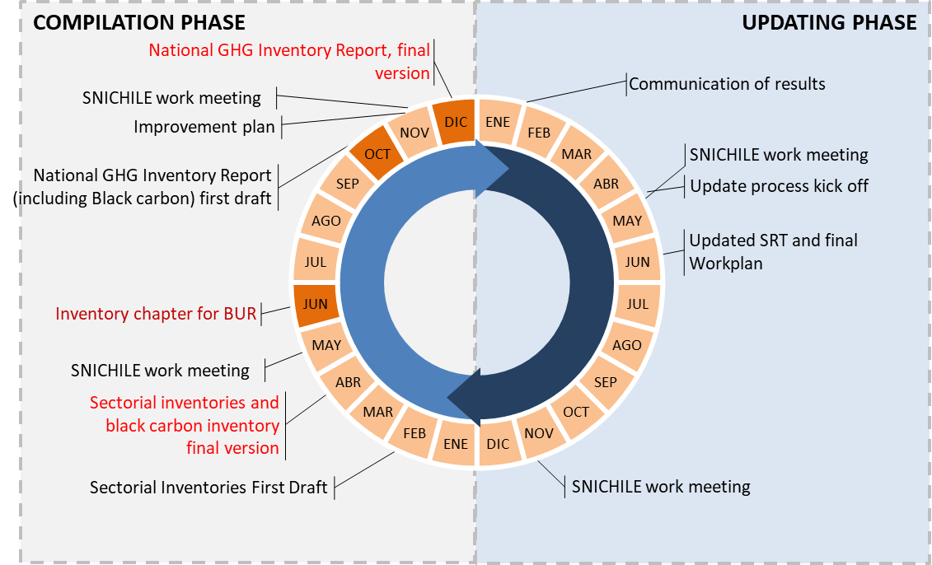

Source: Technical Team Coordinator, Ministry of Environment (Ministerio del Medio Ambiente (MMA))

Each stage of Inventory compilation involves a series of activities and outputs. A more detailed work plan, including interim deadlines for activities during each stage, is outlined in the Inventory Inception Memorandum annexed to the Overview section of this manual.

**Overall Template Progress**

**Table 1‑2** below presents a summary of progress towards completing each template in the National GHG Inventory System Templates series. Also noted are obstacles encountered while completing the templates, and the status of each template, for example, “Complete,” “In Progress,” “Not Started,” or “Not Used.”

### 2: Record progress towards completing each template in the series in Table 1‑2, below.

|  |  |
| --- | --- |
| Purpose | To track progress towards completing all the templates in the series |
| When to fill it in | The NIC should update this table periodically throughout the inventory compilation cycle. |
| How to use it when done | The NIC may find it useful to consult this table before starting another inventory in order to recall the obstacles faced while preparing the present inventory. This way, the NIC may be able to avoid these obstacles in the future. |
| Instructions | As needed, communicate with those responsible for completing the templates in each chapter to obtain the information you need to complete this template. When you have the information you need, fill in the table below. |
| Instructions by column | **Summary of progress towards completing the chapter**: Record a summary of the most important steps taken to complete the template named in the left-most column. Use bullet points or sentences, according to your preference. |
| **Obstacles**: Record the most important obstacles to completing the template. |
| **Status**: Indicate when the chapter is “Complete,” “In Progress,” “Not Started,” or “Not Used.” |

Table 1‑2. Overall Template Progress

| **Template** | **Summary of progress towards completing the template** | **Obstacles** | **Status** |
| --- | --- | --- | --- |
| 1. How to Use the Templates |  |  |  |
| 2. Institutional Arrangements |  |  |  |
| 3. Methods and Data Documentation |  |  |  |
| 4. Description of QA/QC Procedures |  |  |  |
| 5. Description of Archiving System |  |  |  |
| 6. Key Category Analysis |  |  |  |
| 7: National Inventory Improvement Plan |  |  |  |

1. See *Introduction: U.S. EPA Toolkit for Building National GHG Inventory Systems* for more information about the national GHG inventory compilation cycle, including a helpful diagram showing the sequence of stages.
2. See 18/CMA.1, Modalities, Procedures and Guidelines (MPGs), Annex Chapter II, [Section B., National Circumstances and Institutional Arrangements](https://unfccc.int/sites/default/files/resource/CMA2018_03a02E.pdf) guidance for National Greenhouse Gas Inventory Reports (available at http://unfccc.int/decisions).